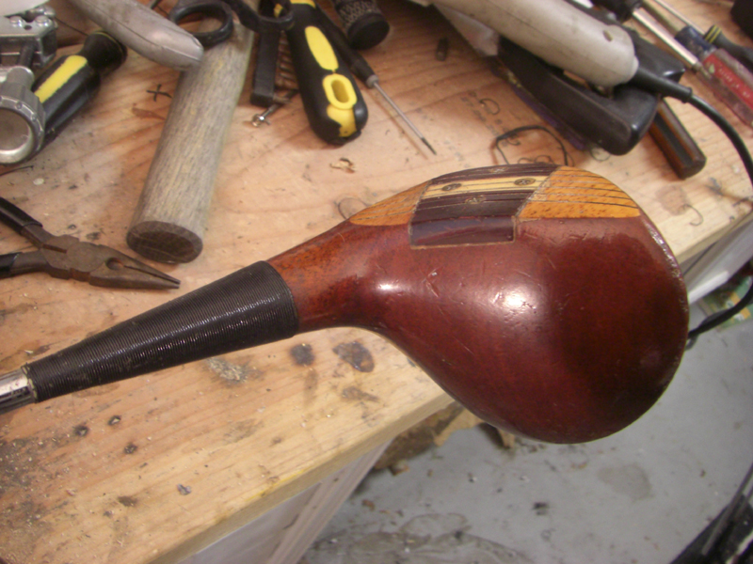

Starting here with a 1970’s very nice Titleist Persimmon Driver. We are going to re shaft this thing, and flatten the lie angle to 50 degrees so we can swing properly on a flatter swing plane as so many of golf’s great ball strikers did from the past. A flatter driver encourages a more pivot or body driven golf swing, and it’s also much harder to hit the ball off line from a shallower swing plane. The great ball strikers of the past like Hogan, Trevino, Knudson, Player all knew this little secret of the game.

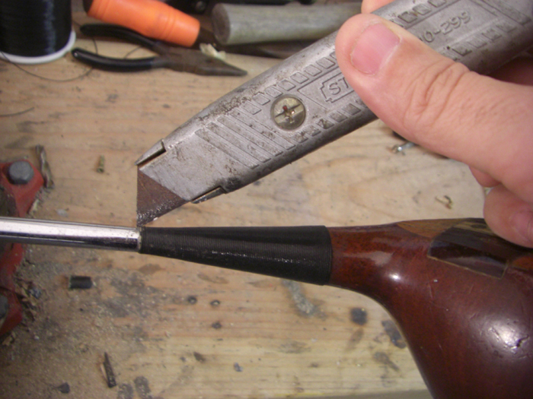

Before we reshaft and refinish this old cat, let’s remove the whipping with a razor blade. No worries here, just cut it off.

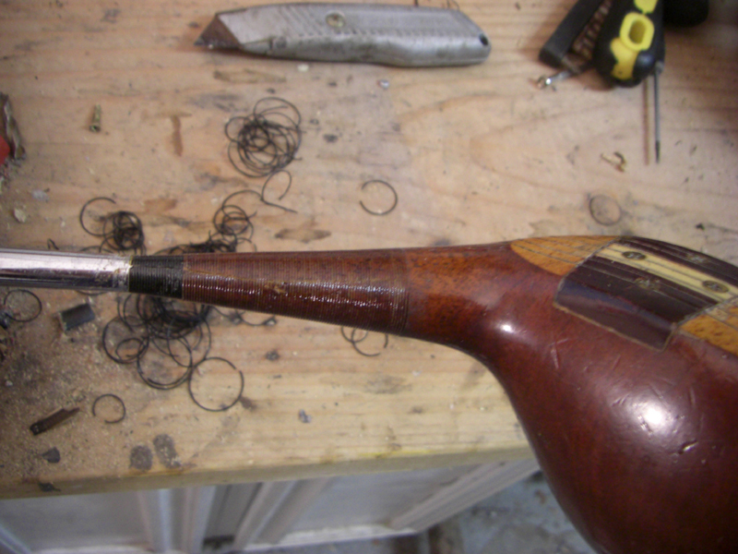

No cracks in the neck.. good.. if there are.. no big deal.. today’s epoxies are great.!

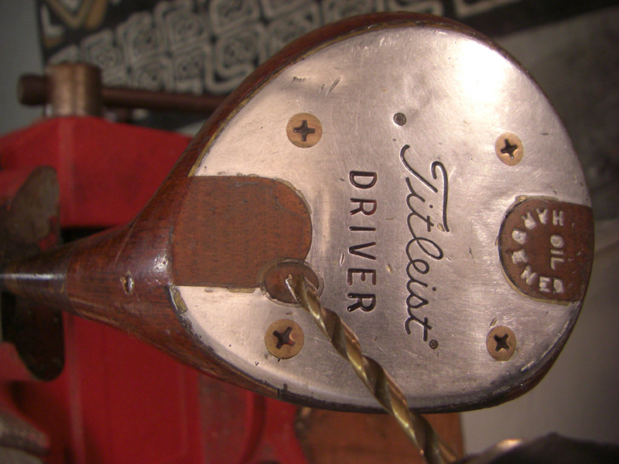

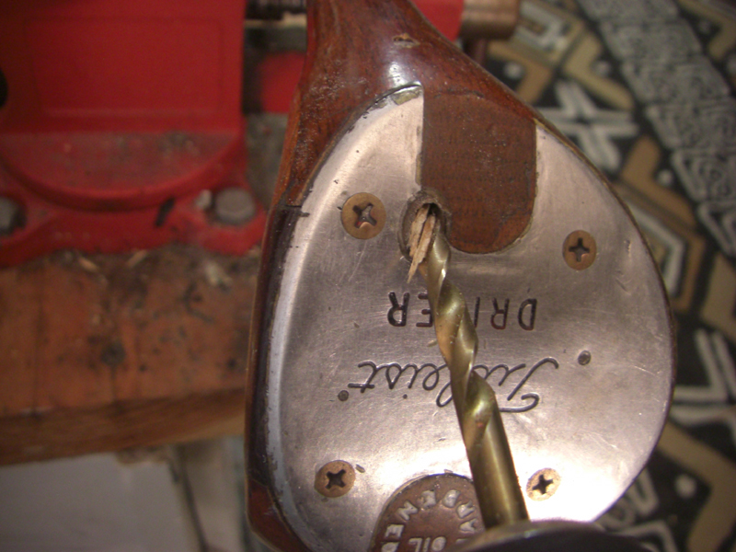

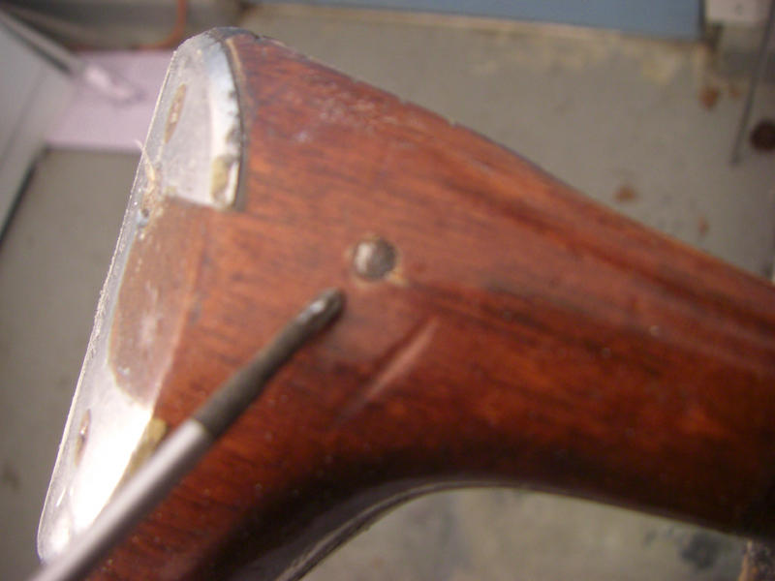

These pins can be a nightmare.. this one is no exception!

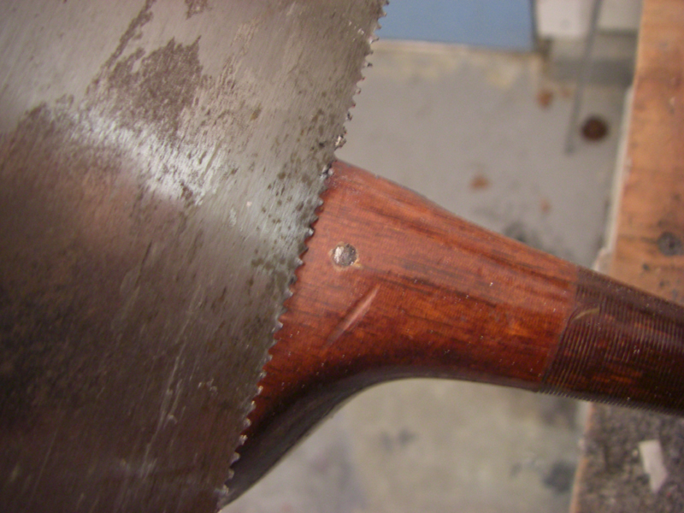

This one we simply are going to cut out. Sometimes you can drill them out from the bottom hole, but no luck here. We have to get it out to get the shaft out.

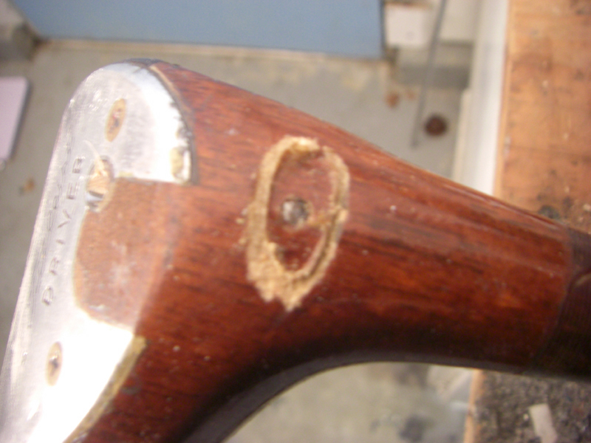

Two cuts from each side.

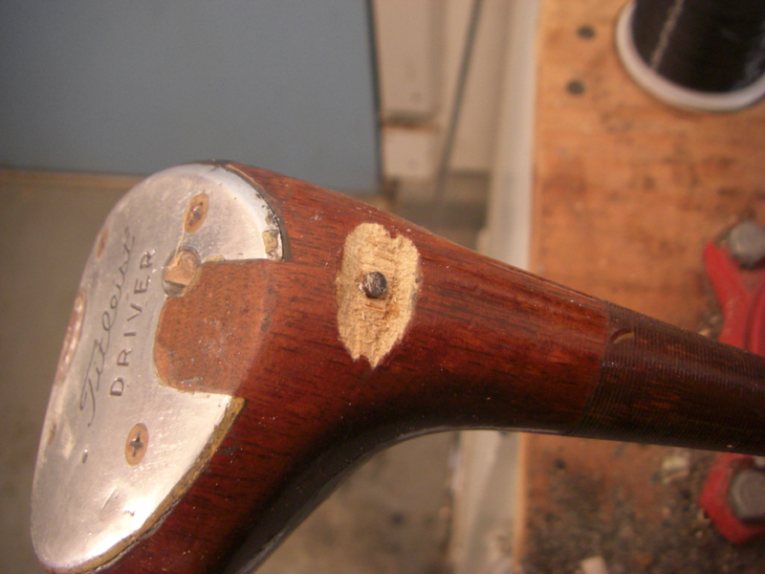

Remove the wood so we can get a pair of vice grips on it and back it out.

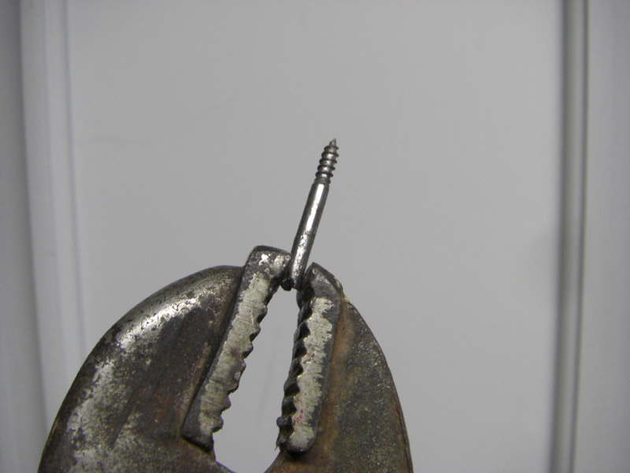

vice grips should be in every tool case!

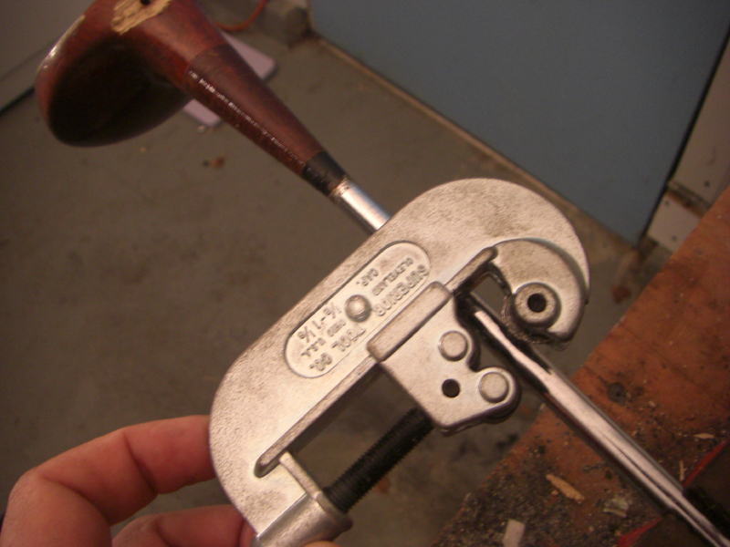

A simple pipe cutter will cut any steel golf shaft with ease.. this one was $10 at the hardware store.

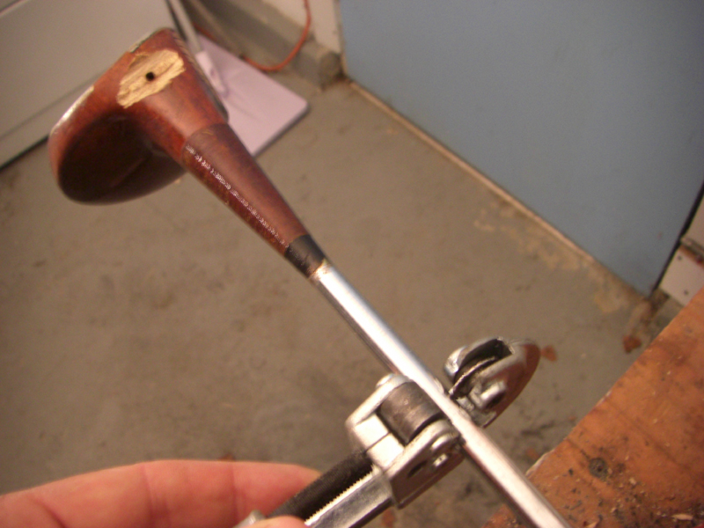

Wrap it around, and tighten it from the bottom more and more with each turn. Just keep spinning it around the shaft until it breaks loose.

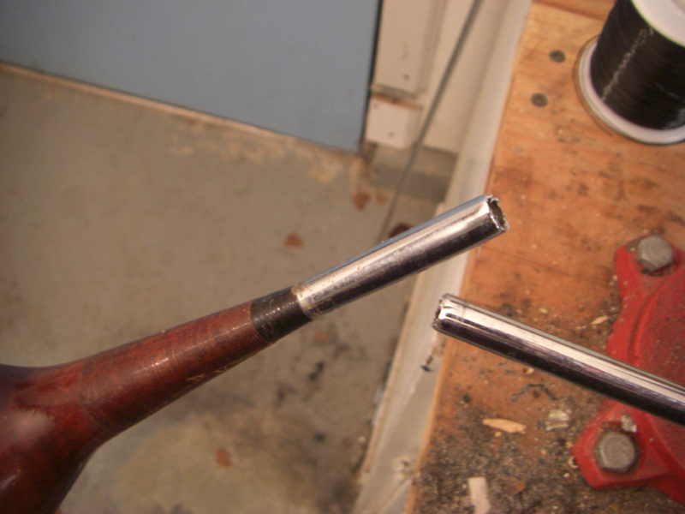

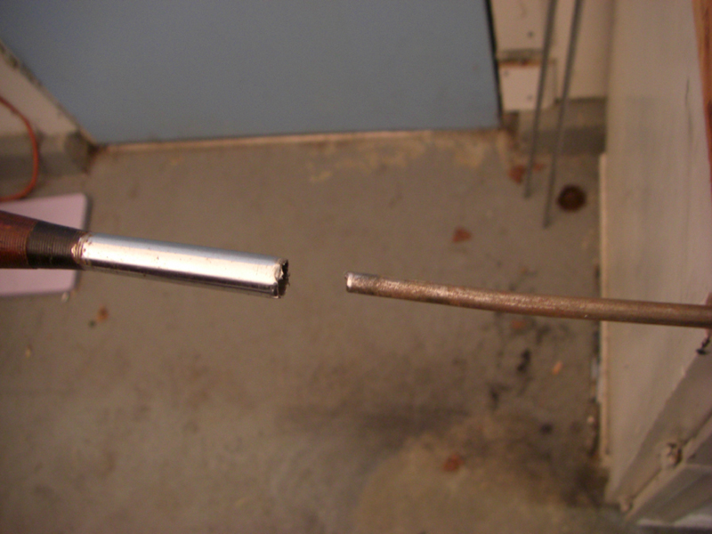

Now, we need a solid metal rod we can put inside the cut off shaft. We will heat it up, and place it inside the shaft. This breaks the old epoxy bond so we can then easily twist the head off the shaft.

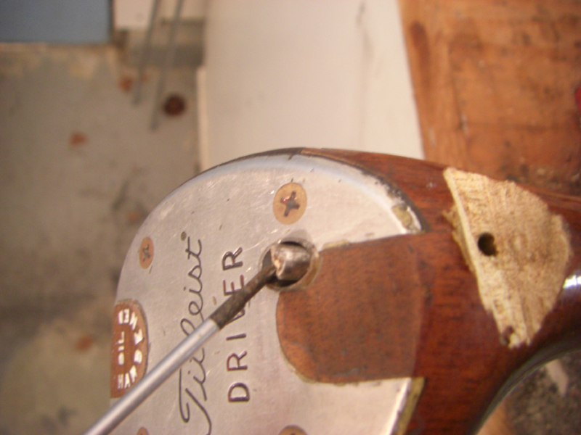

We want to push the rod all the way through the shaft.

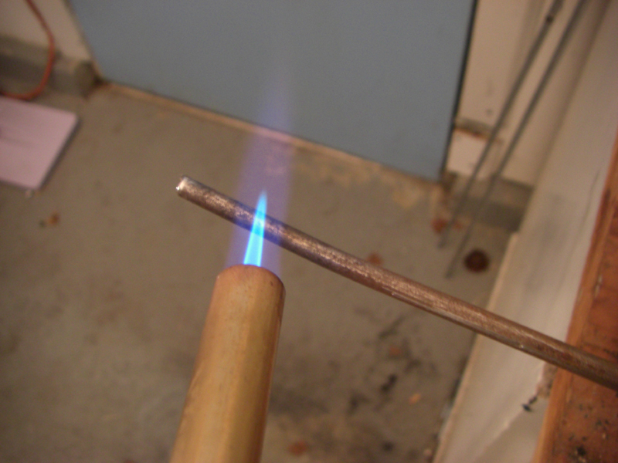

Heat up the tip first with a blow torch, till it’s red hot.

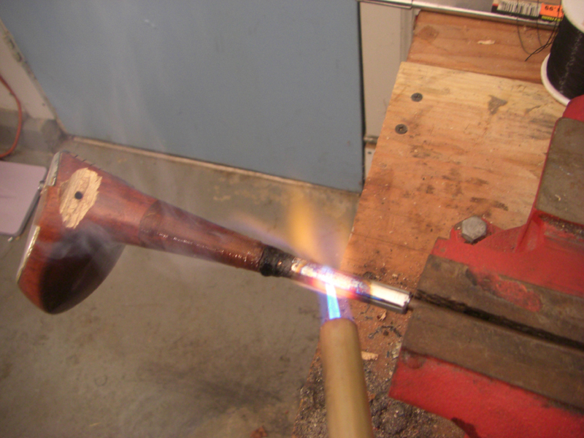

Place inside the club, and then heat up the outside end for a couple minutes.. RED HOT!

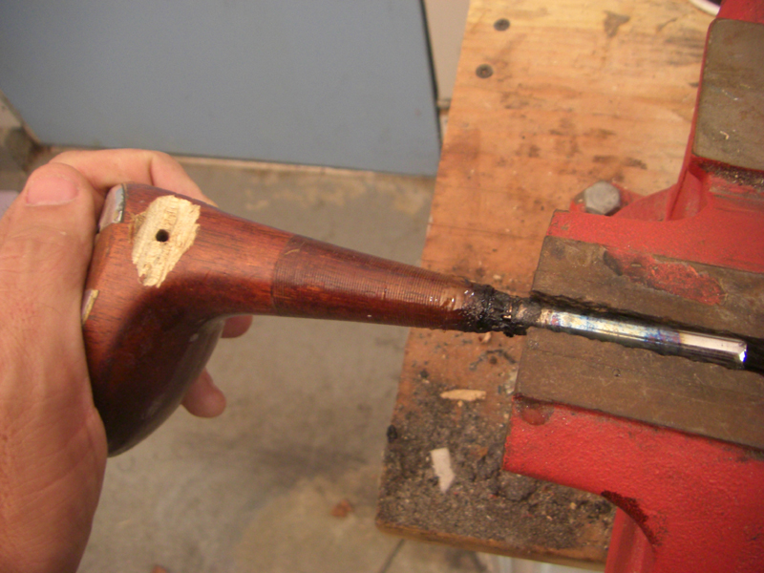

If you burn a bit of the wood, no big deal, we are going to be cutting some of that off anyway. Let’s twist off the head….

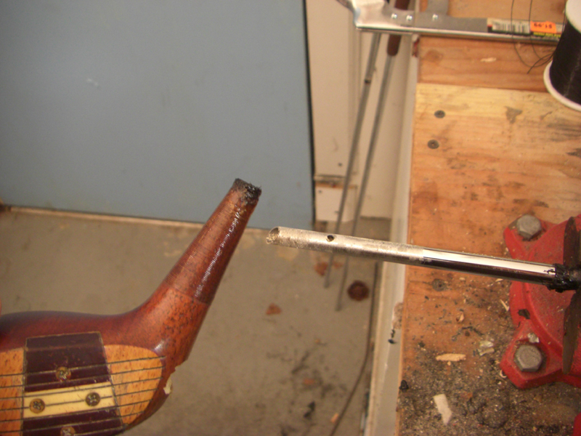

That was easy!

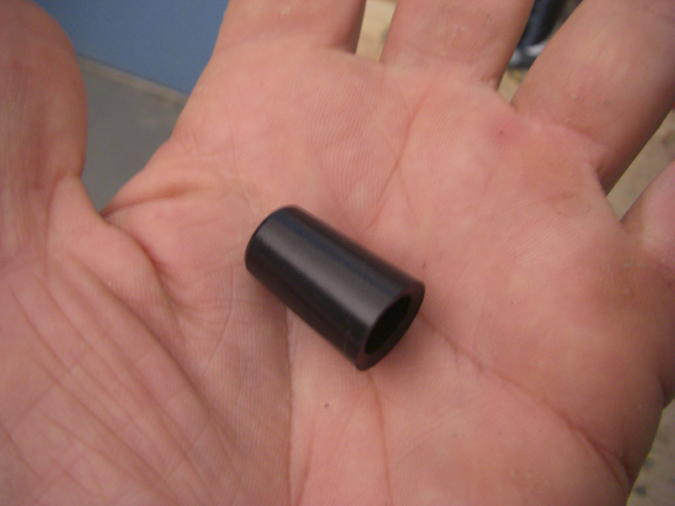

This is a ferrule that would usually be used for an iron. We use this to shape our new flat neck.

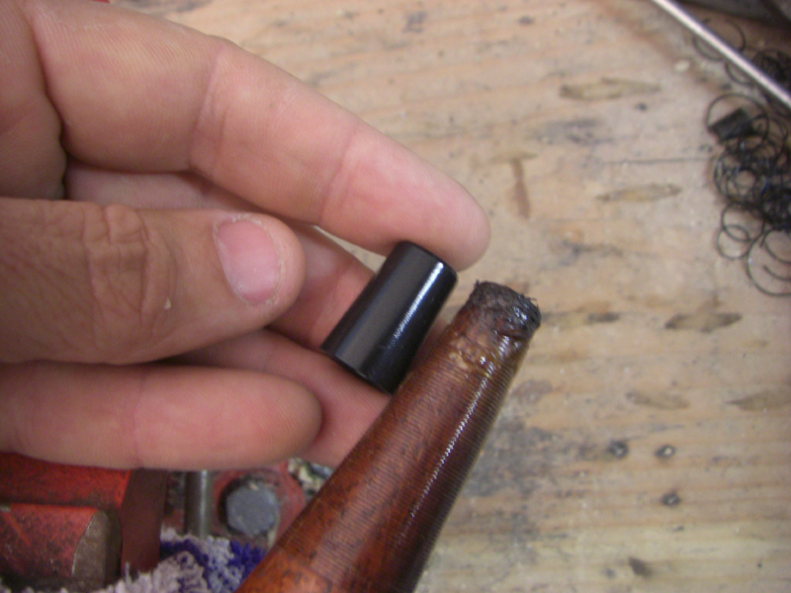

Measure and mark on the neck, and we are going to cut off a piece of the neck the length of the ferrule.

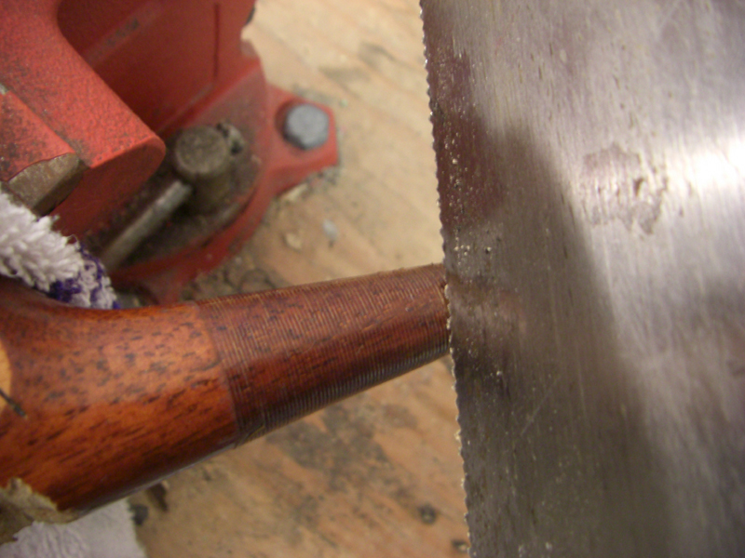

Since we are going to flatten the club, let’s cut it about 10 degrees clockwise to the right. This will make it easier for us when we rebuild the neck. No need to worry here. Any cut will do really… just trying to save some time and sanding.

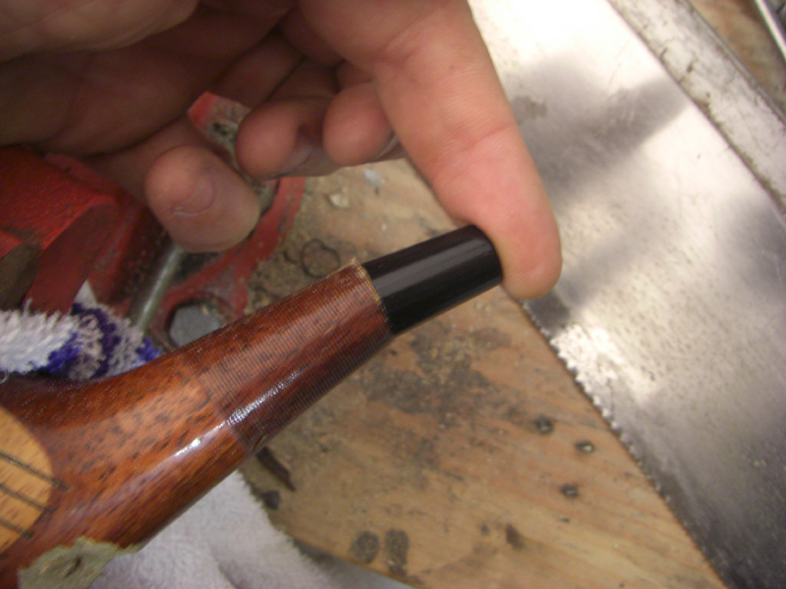

This is how we should make it look.. a bit of a goose neck. You can see the new path is going to be flatter than before.

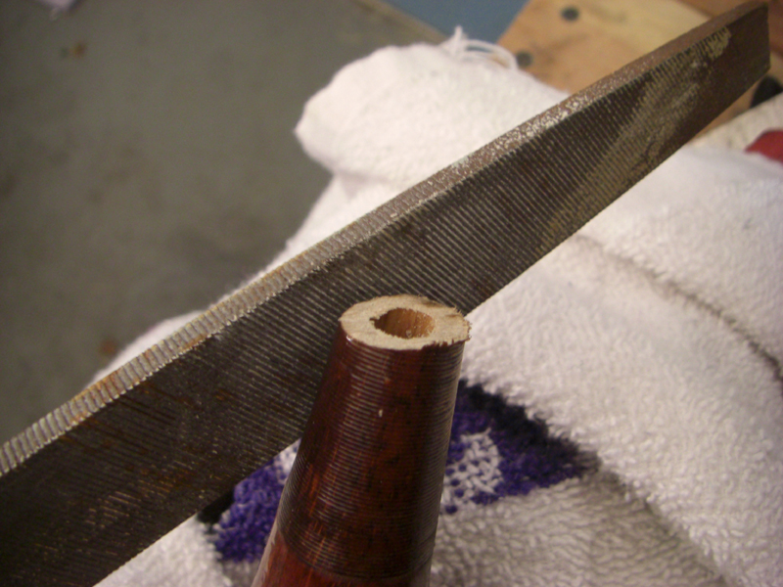

file down the rough edges.

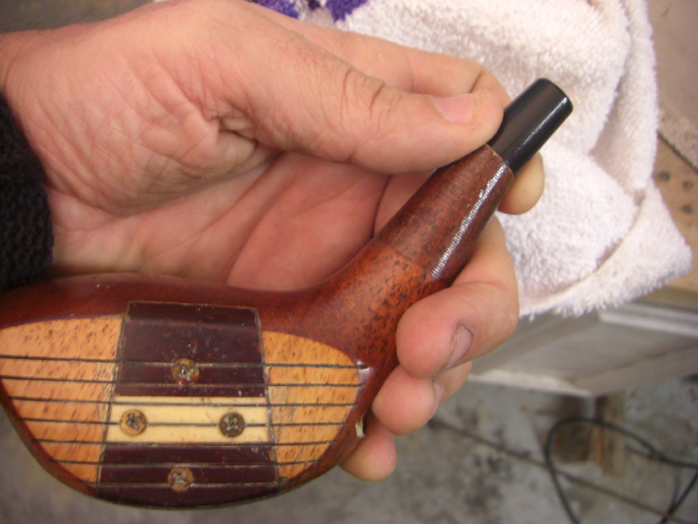

Just like this…

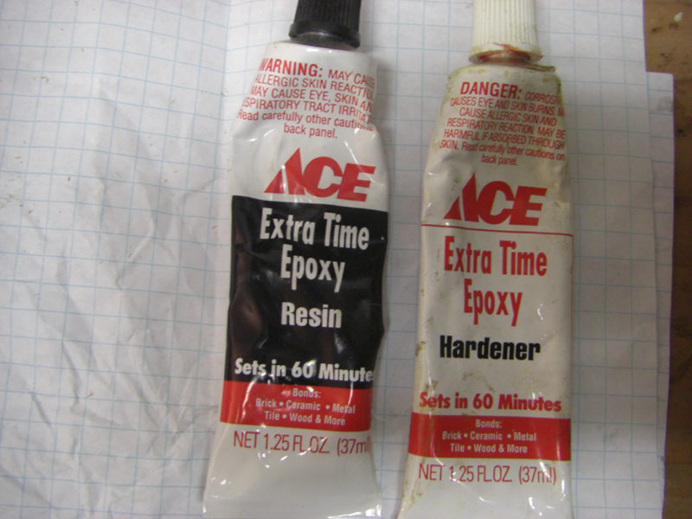

Let’s mix up some glue… make sure to use a slow curing epoxy.. no need to be in a hurry, just like our golf swing.

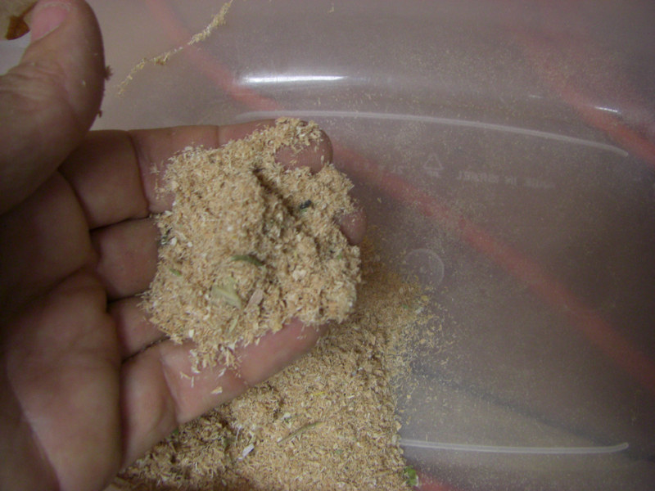

Just saw dust here …

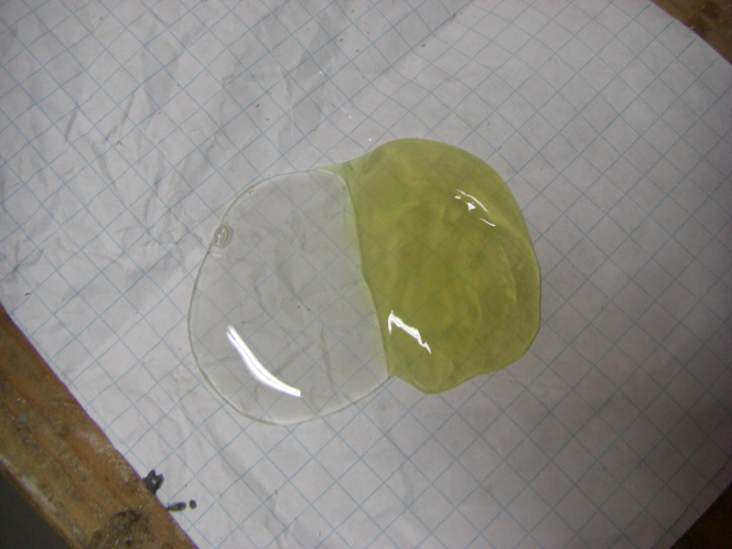

Equal parts..

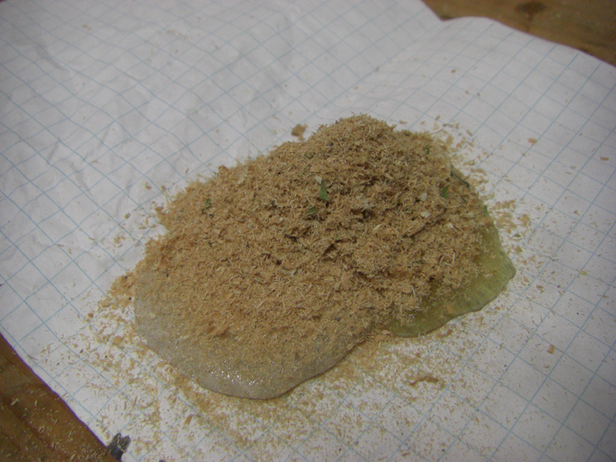

Mix in some sawdust.. about an equal amount.. this makes for a strong bond.

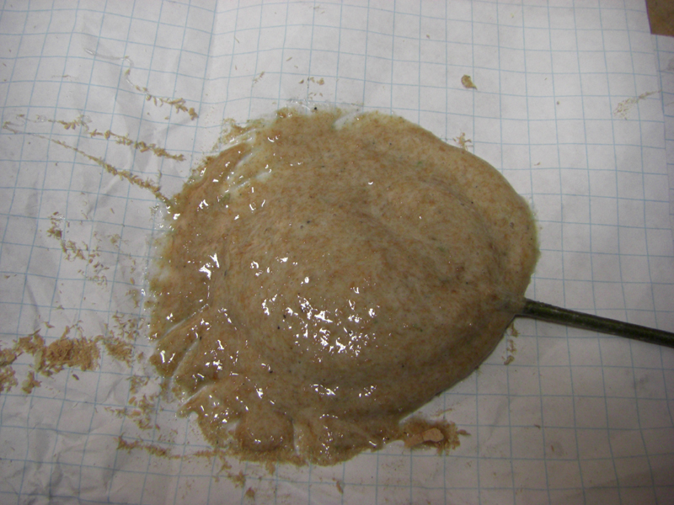

Think toothpaste

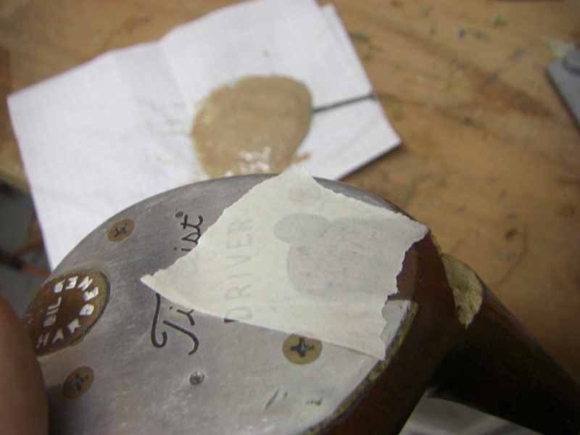
cover the hole

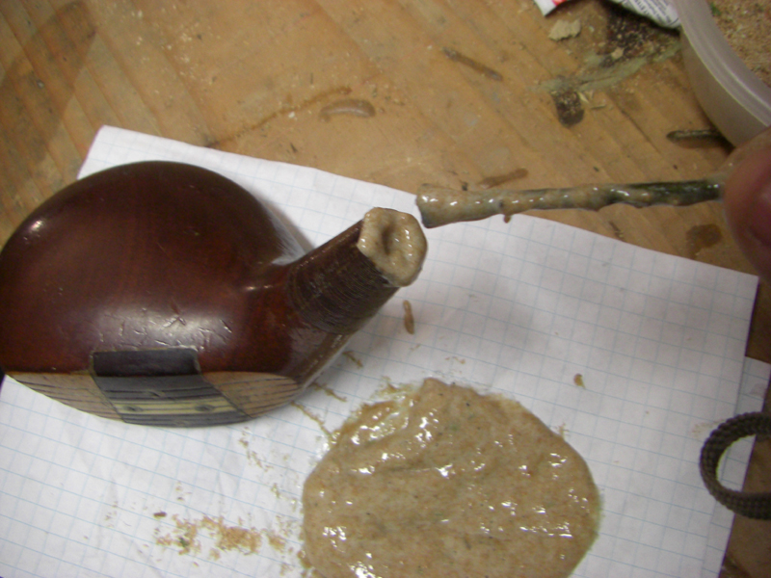

fill up the hole with the gooey stuff..

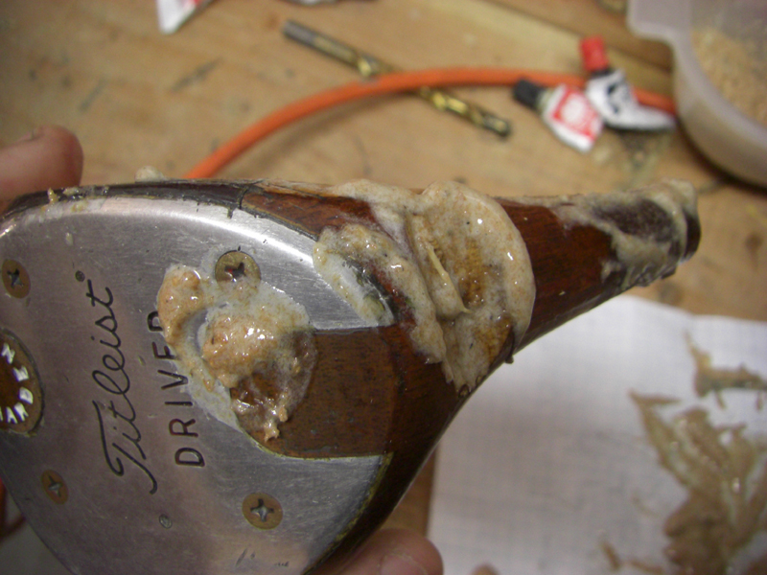

Make sure it oozes out of the bottom and the side where we removed the pin.

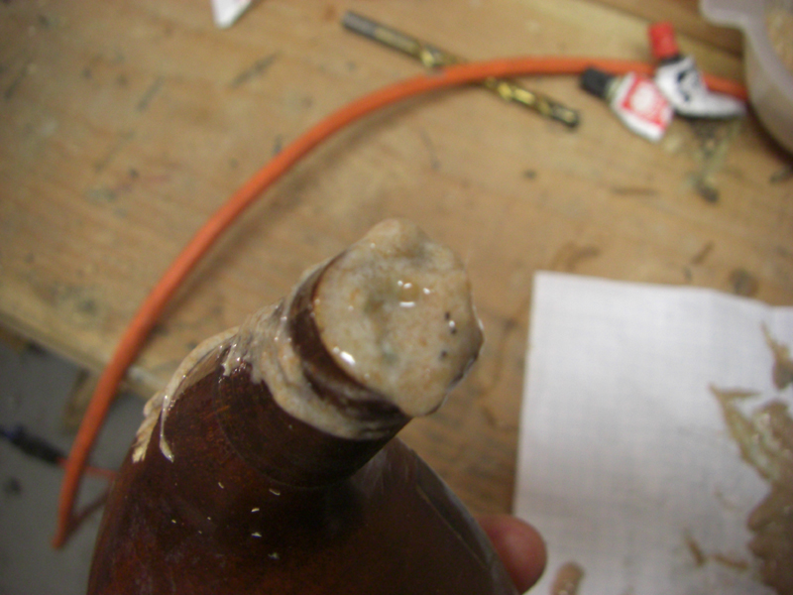

Fill it to the brim

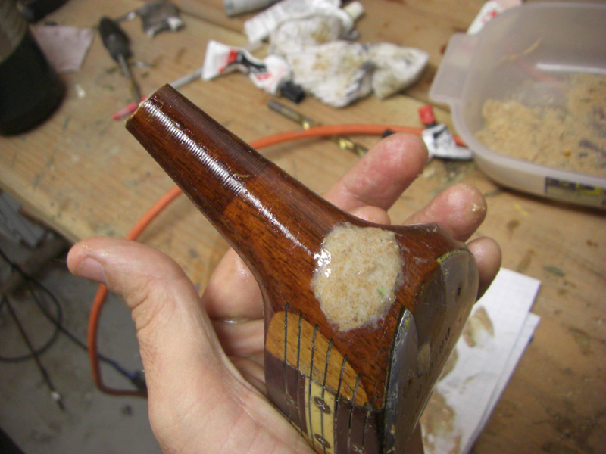

Fill in the cut you made.. like replacing a divot.

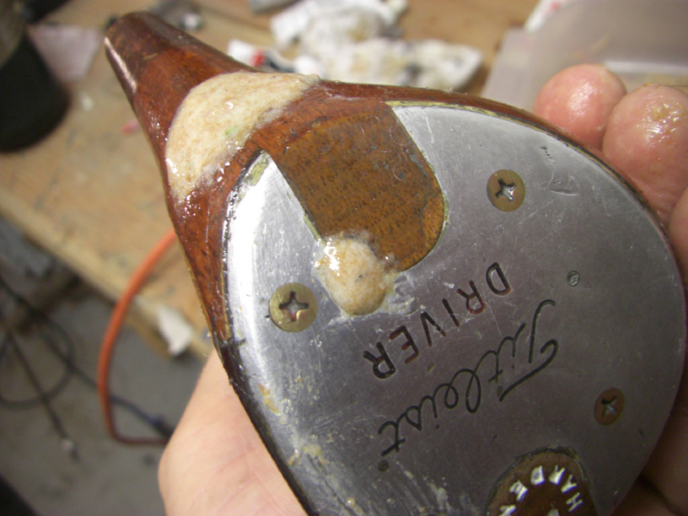

Shape it in there the best you can…

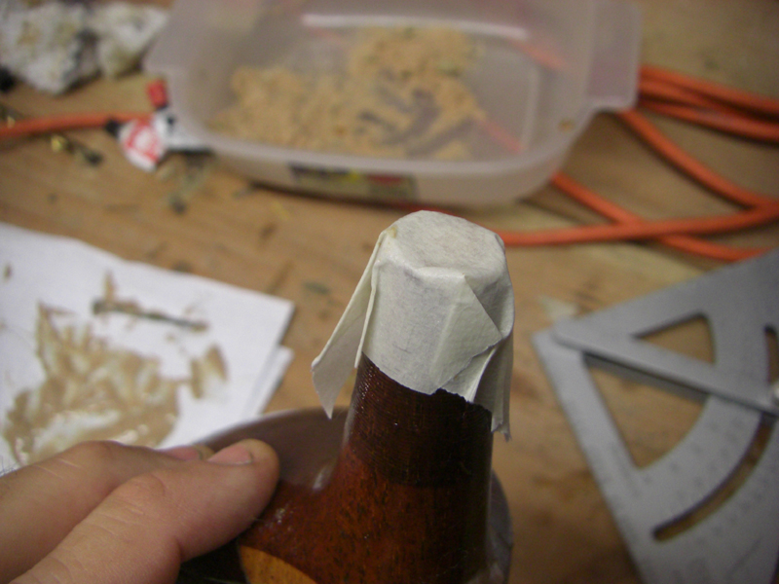

Tape it all up.. top and bottom

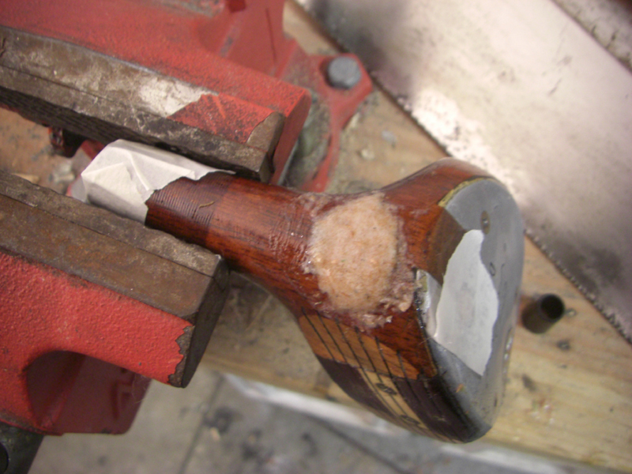

Put it in a vice and let it sit over night.. it’s ok to dream about hitting this thing again!

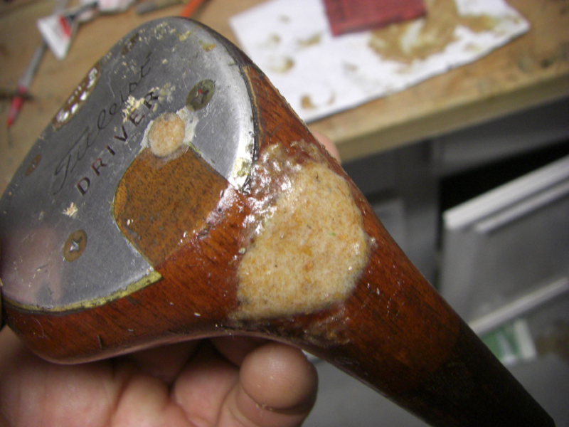

The morning after

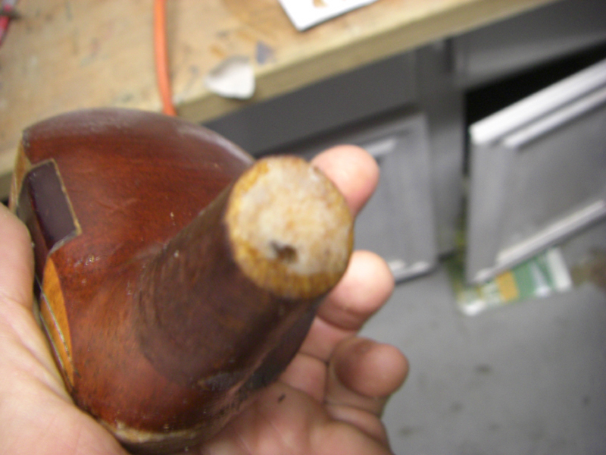

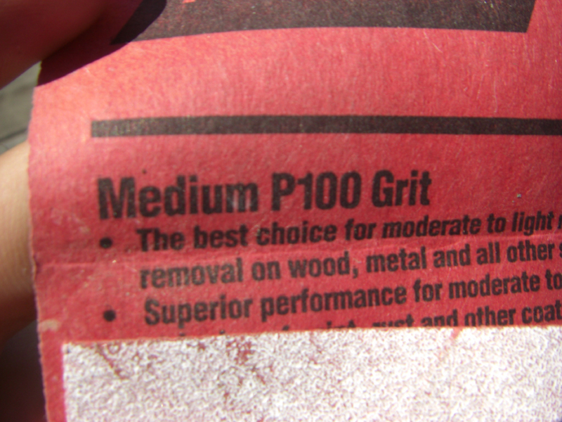

I like to start with 100 grit… works fast..

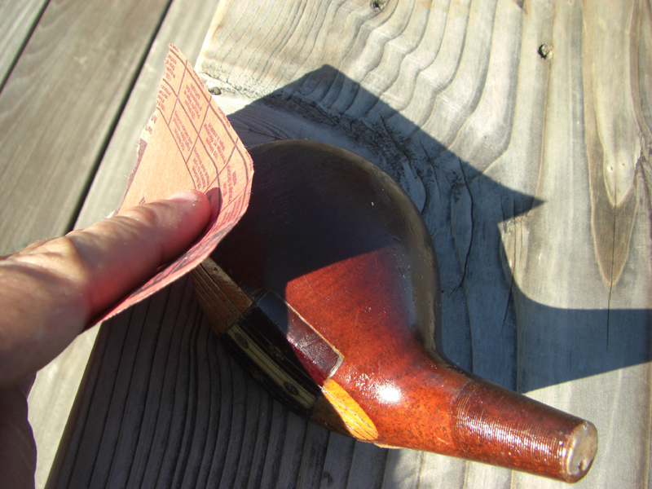

Time to sand down this club.. I like to do it by hand.. took me about an hour to sand this club all the way down.

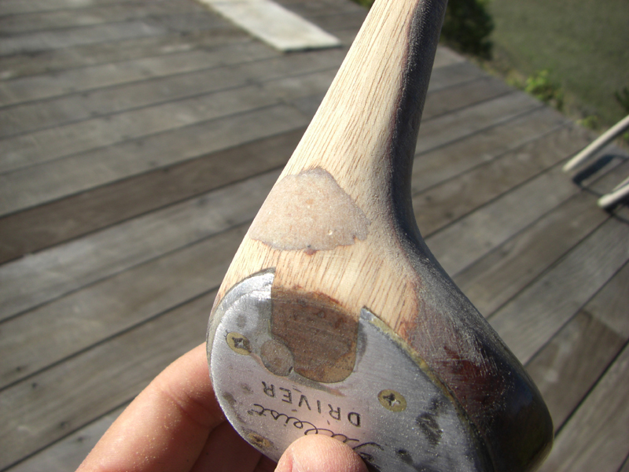

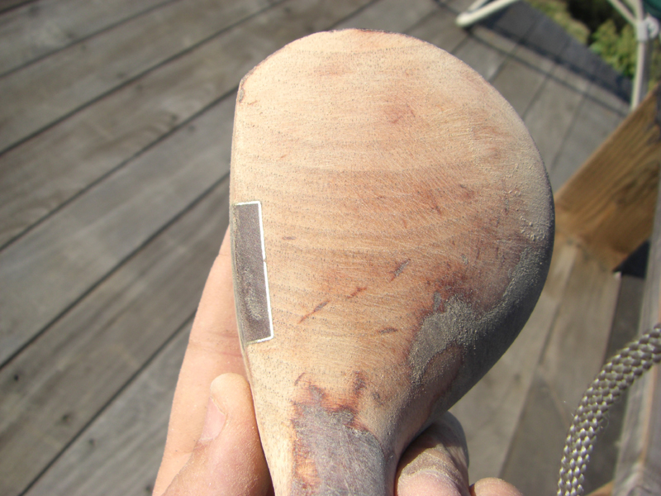

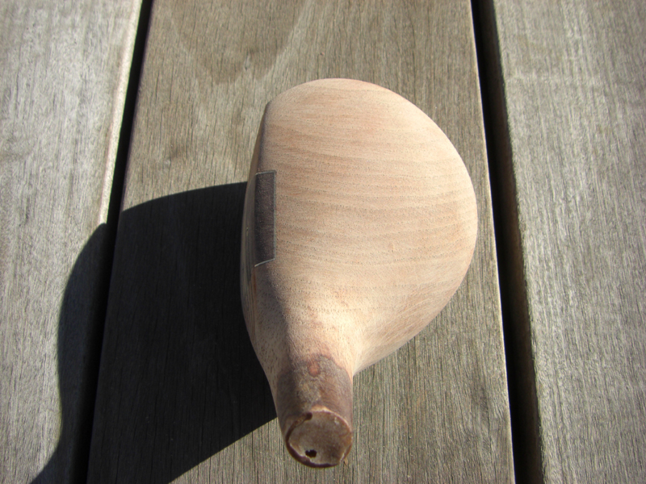

That was fun…! and this club has perfect grain.. nice and tight with the eye right at the top… a real beauty!

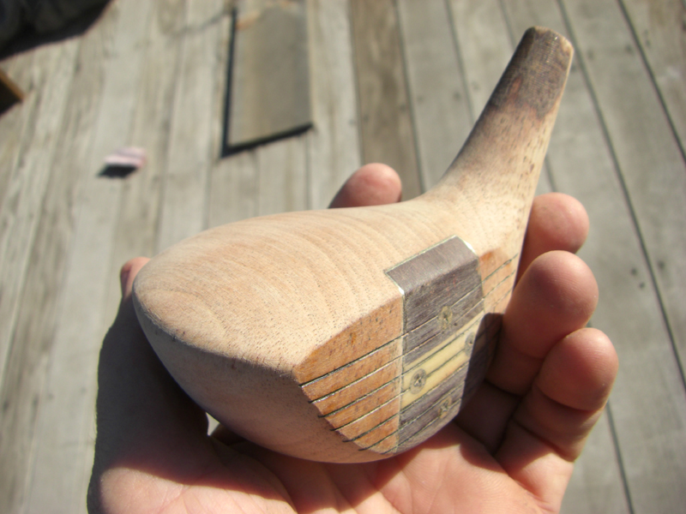

What a beauty!

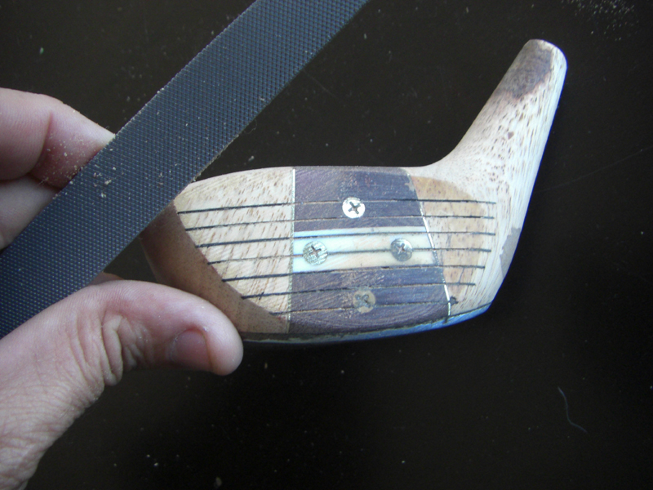

I like to use a metal file on the face.. clean it up some, and you can even change the loft a bit if you so dare.. shape it anyway you like..

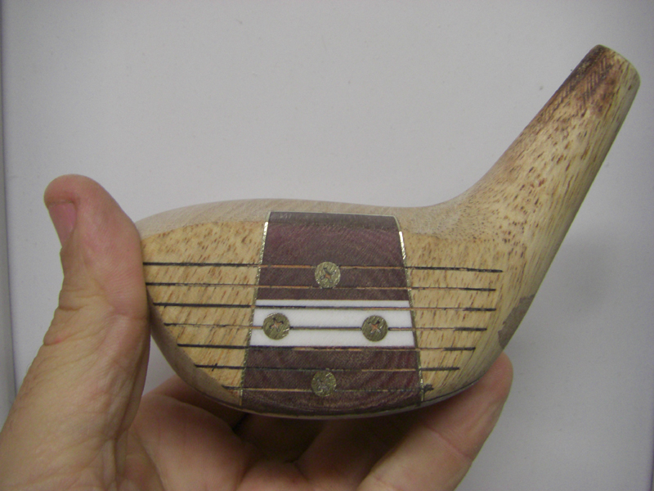

This one cleaned up nicely… Love the “Eye O Matic” style inserts..

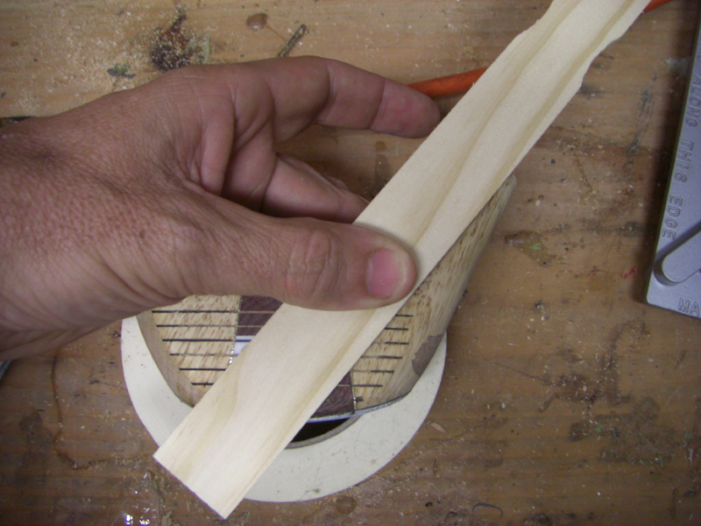

Now we draw a line to help us drill out the new hole..

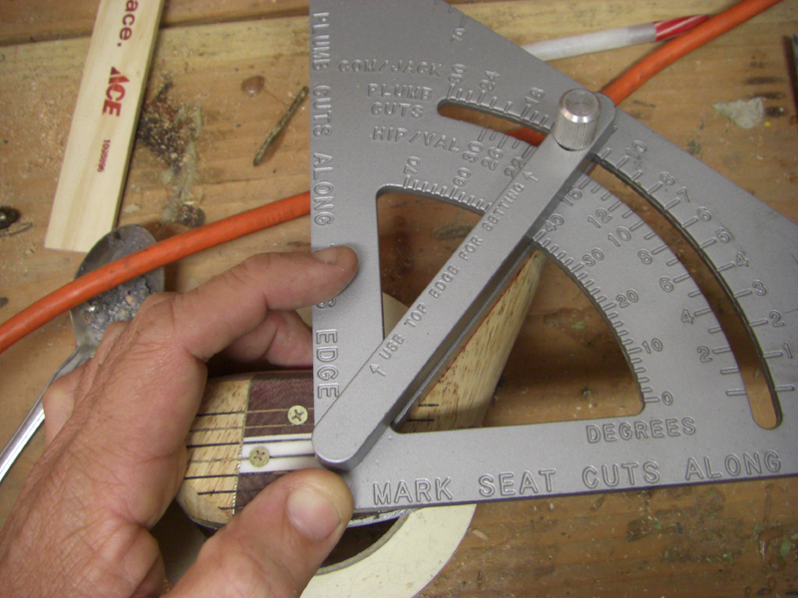

A pro tractor and I’m setting this one at 50 degrees..

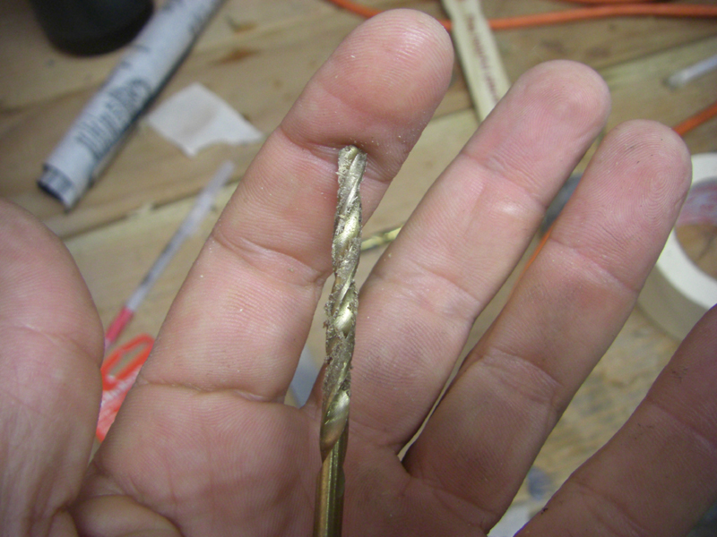

I start with a 1/4 inch drill bit.. and then go to a final 3/8ths inch bit.

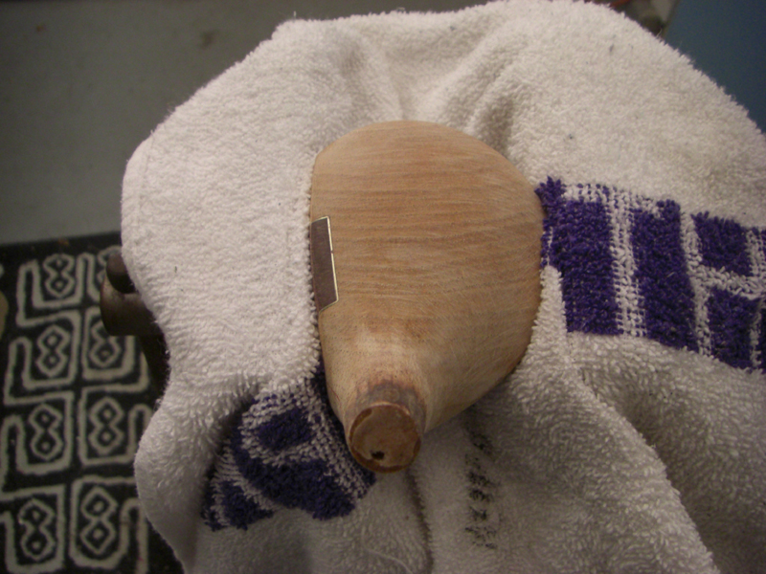

Locked into a vice with a towel…

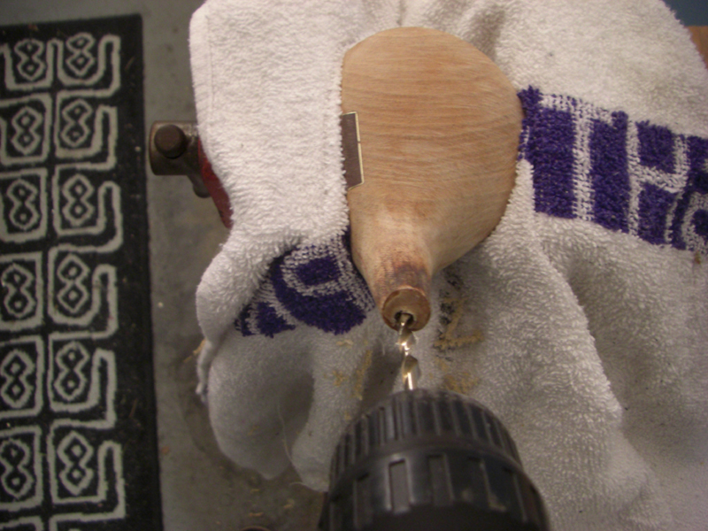

get drilling..

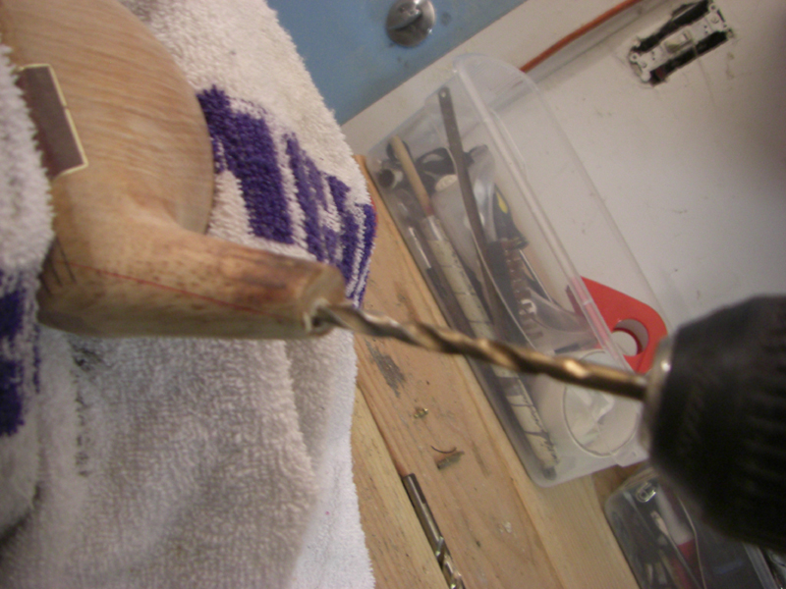

Keep an eye on the side line you drew…. just do the best you can.. it’s not as critical as you think.

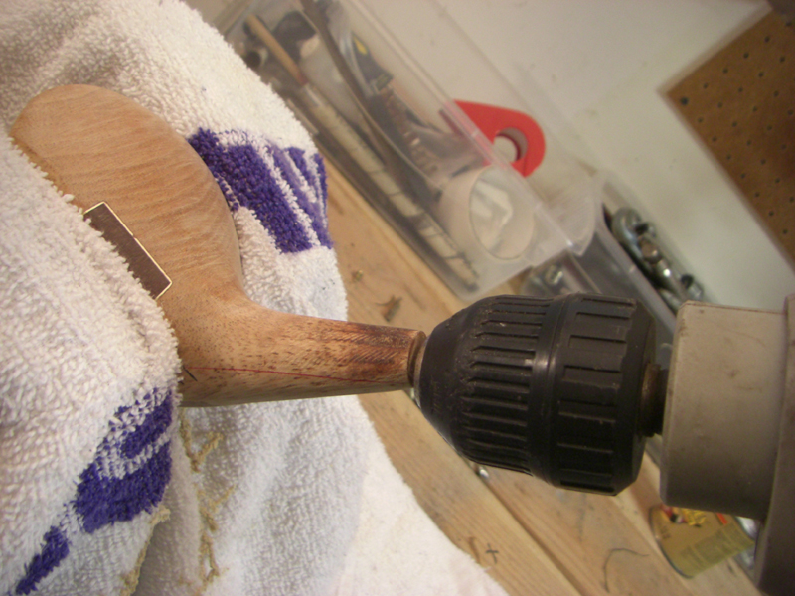

Right through.. to the sole plate.. since you are going in shallower.. you will miss the old hole, and be more toward the center of the club than before.

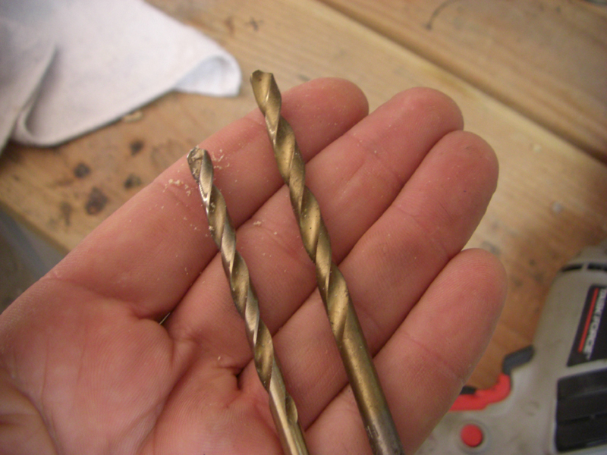

I just use these two bits..

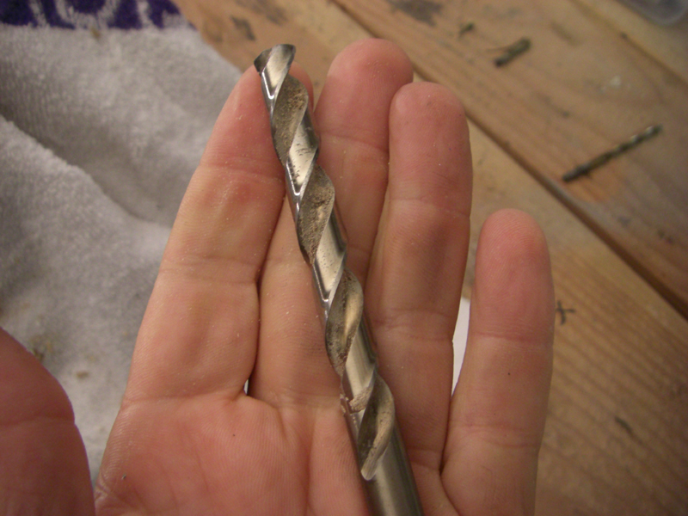

Here is the 3/8ths .. it’s the perfect size for driver shafts..

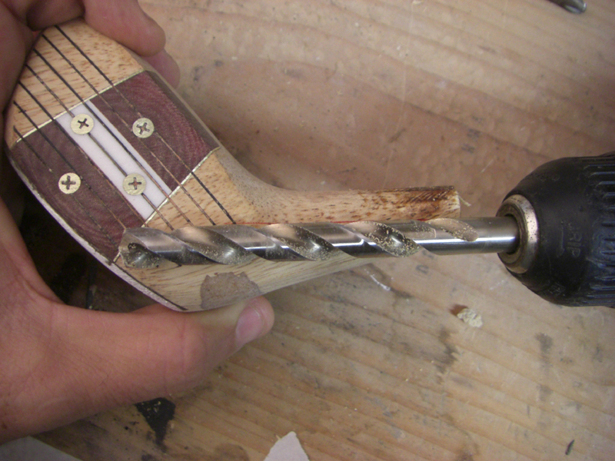

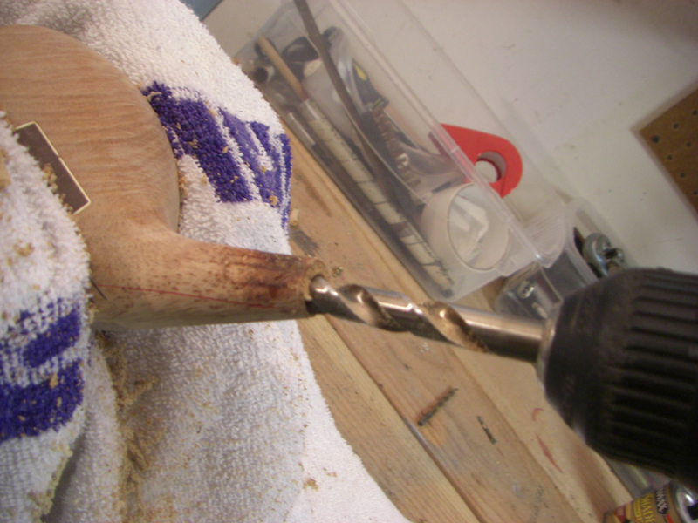

Take you time.. no hurry..

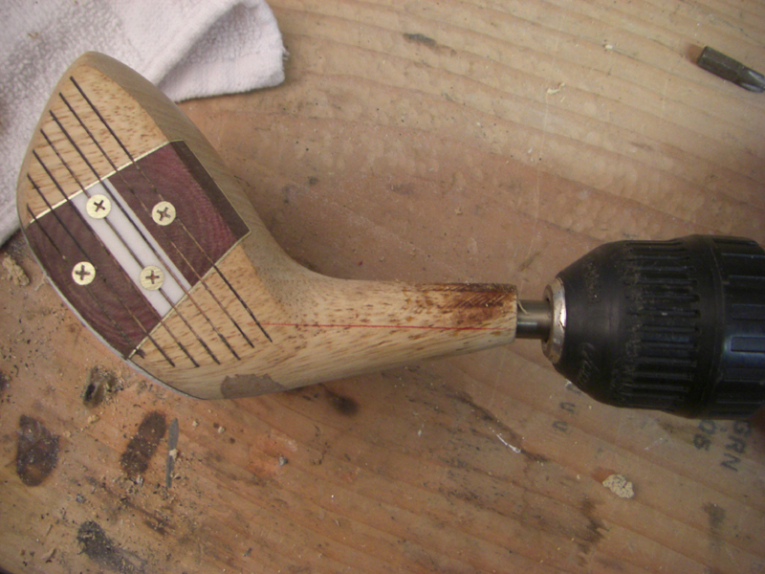

Looks like a good line..

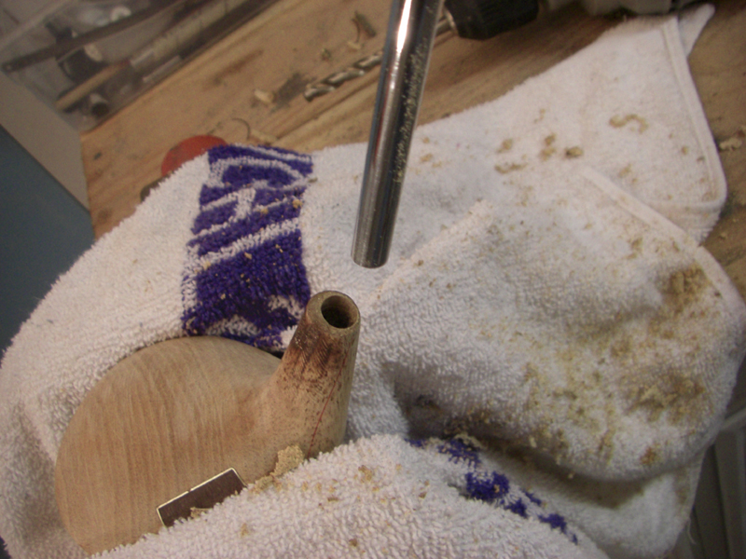

Let’s check with a shaft..

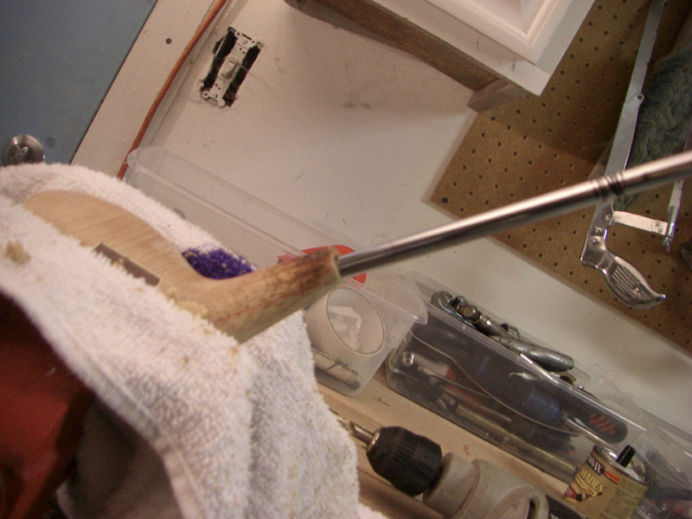

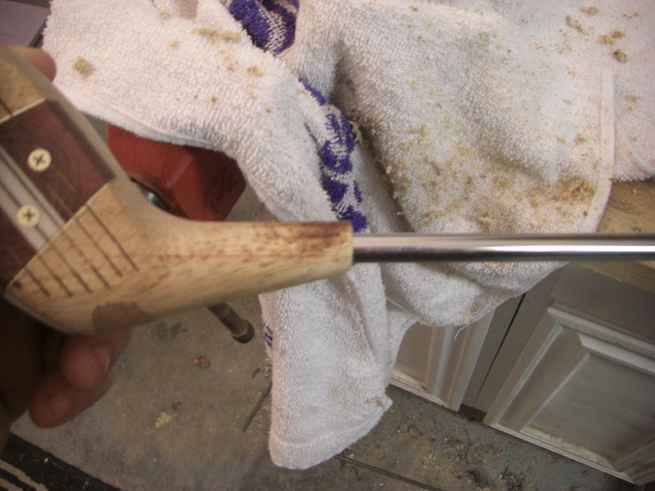

Looks good..

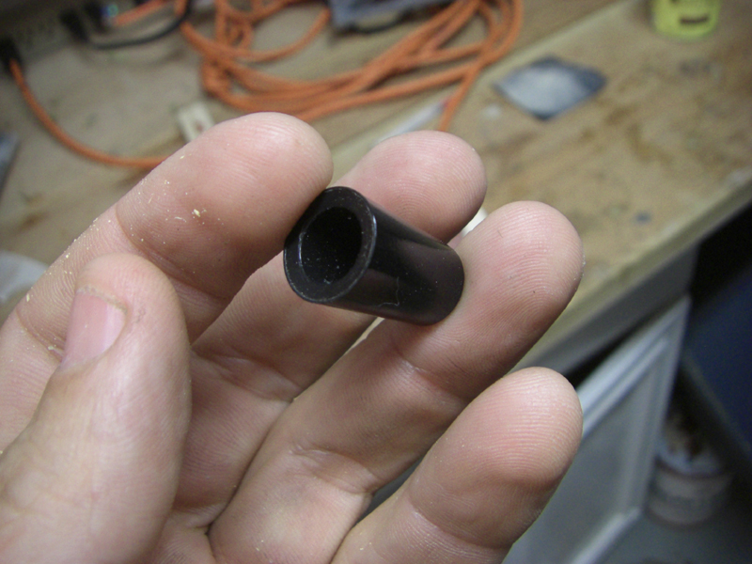

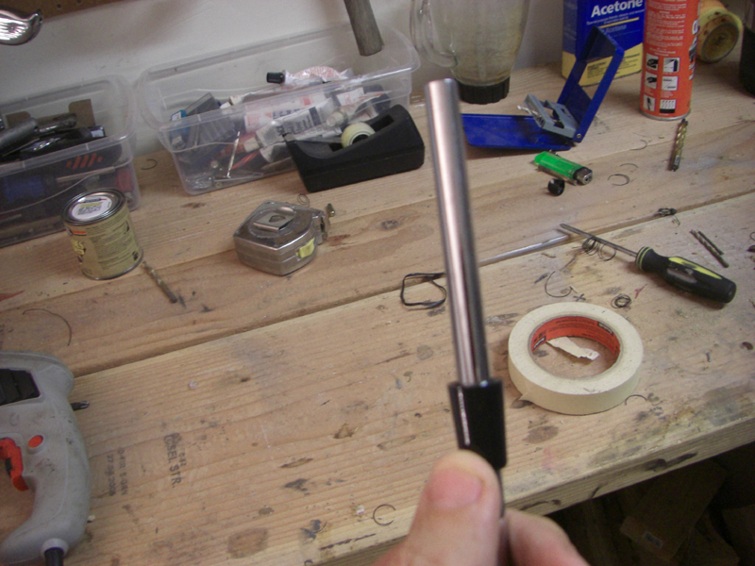

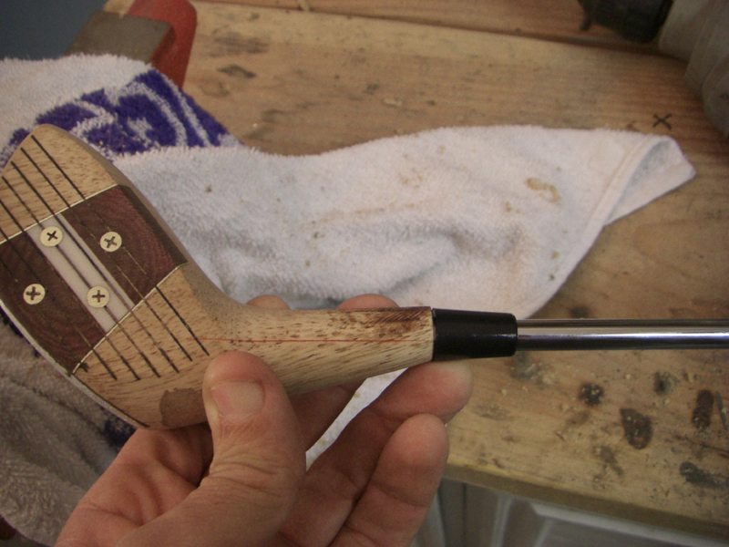

Here is why we had that ferrule..

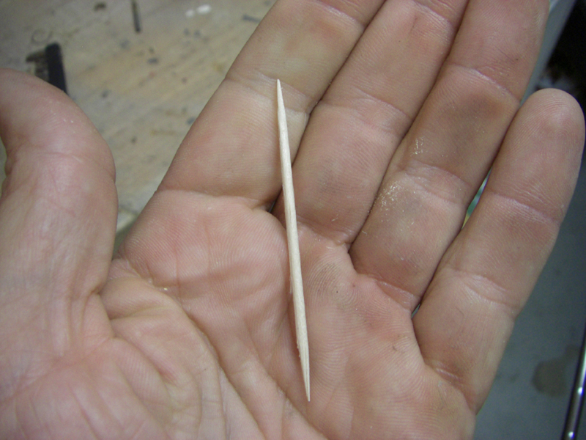

We use an everyday toothpick as a shim as there will be a little bit of play when we put in the shaft.. this is great because we can then adjust the lie and look of how we want the head to sit to our eye. I like my drivers really square, not hook faced… if anything slightly open so I can really release hard into the ball.

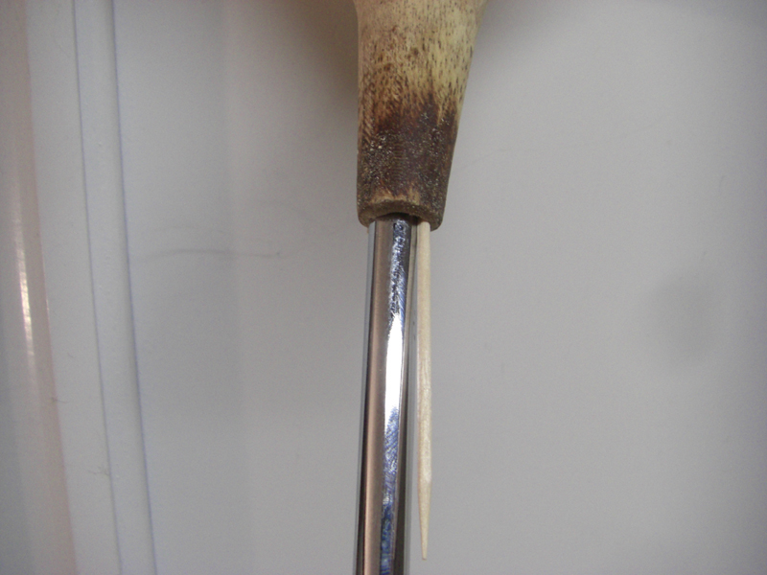

After fiddling with it on the ground… for this club, I shimmed it on the right side.. just shim yours however you like it…

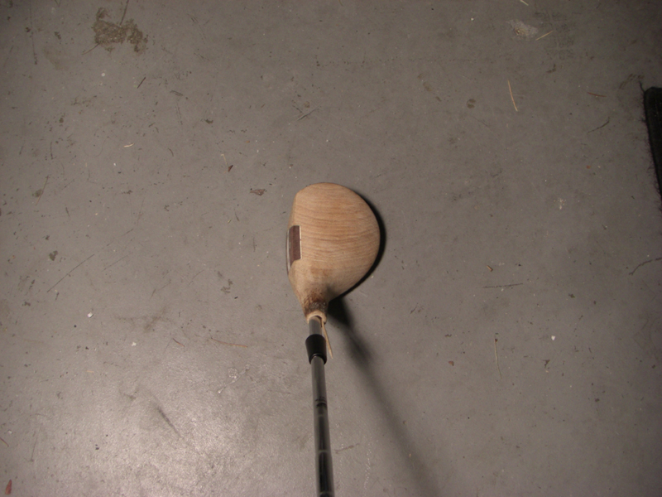

That’s how I like my persimmons to sit.. nothing like custom work just the way you like it.!

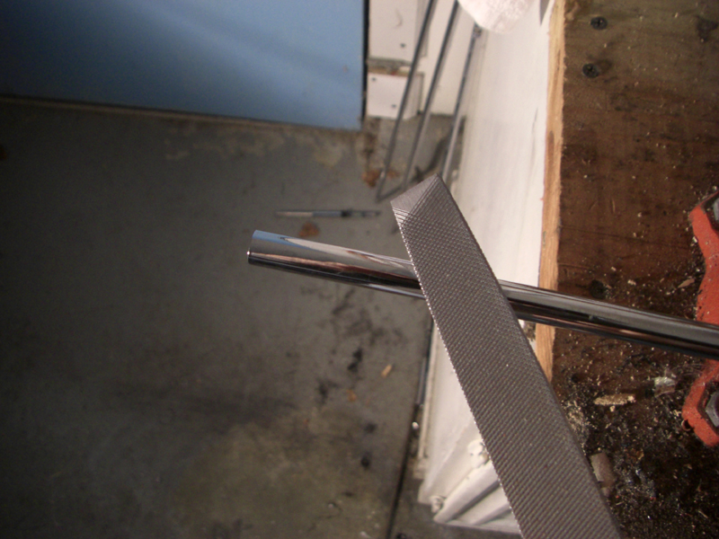

Before we glue in the shaft.. let’s rough up the shaft with a file. That will help it hold the epoxy..

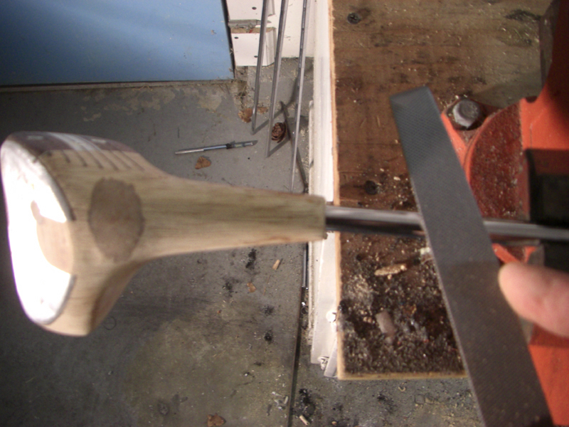

Make sure to include the extra length of the ferrule.

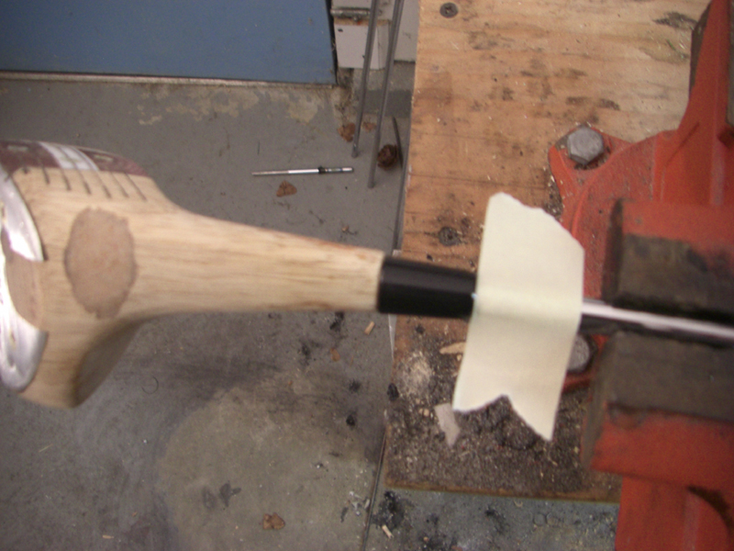

I put a piece of tape as a guide

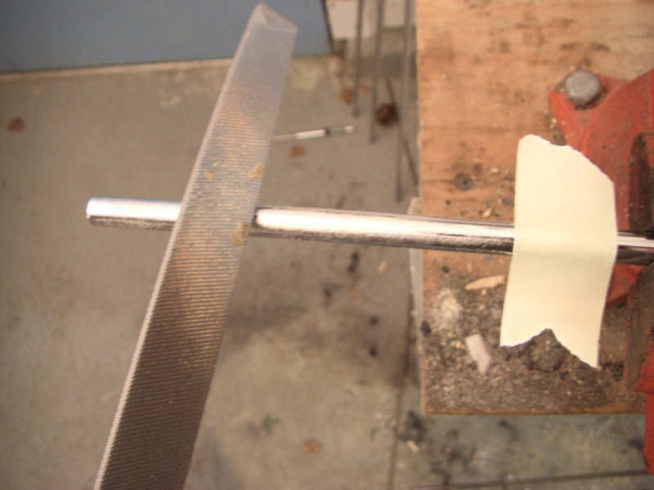

Pull the shaft back out and rough the whole thing up…

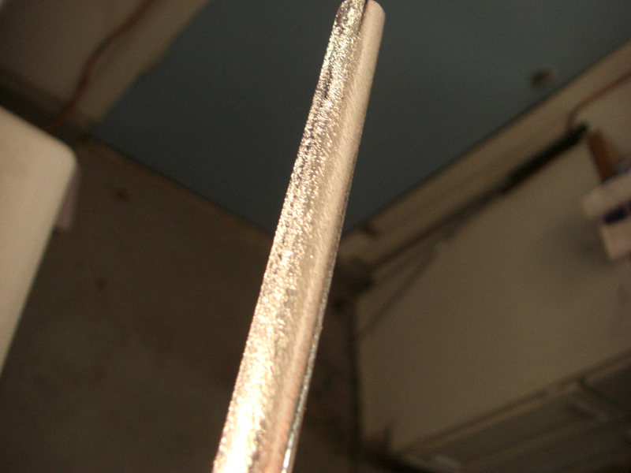

Take all the shiny glaze look off.. the pro’s use a power tool.. you can too.. but I just do it by hand with a metal file. MAKE SURE TO PUT THE FERRULE ON BEFORE YOU GLUE!

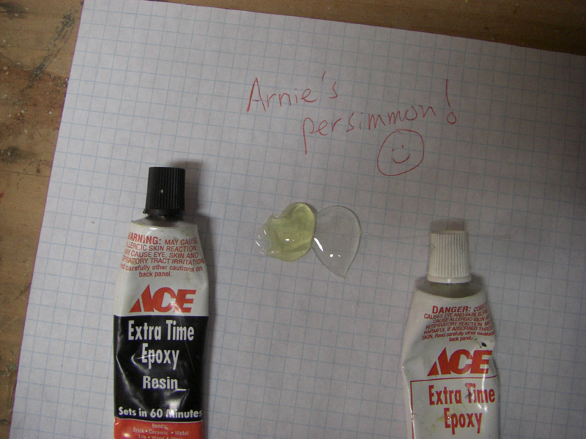

Back to the glue..!

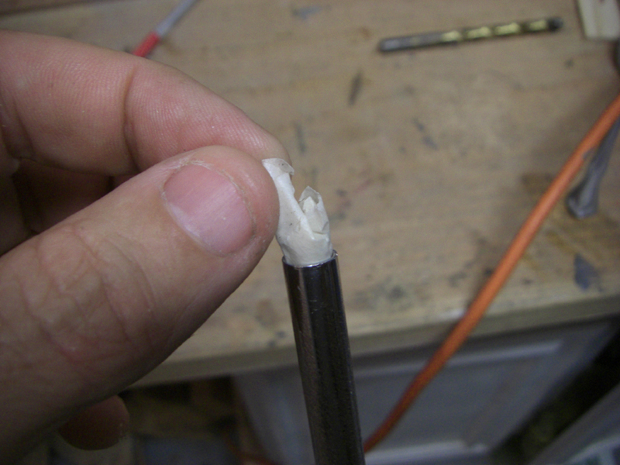

I like to fill in the tip of the shaft with a wad of tape so the glue doesn’t go up the shaft.

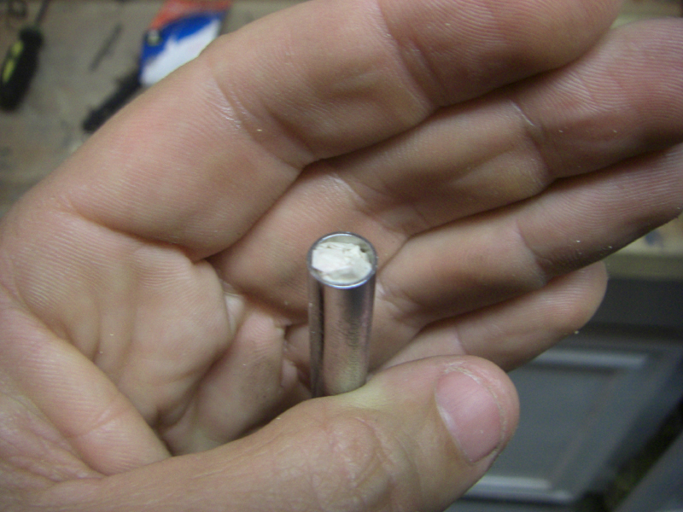

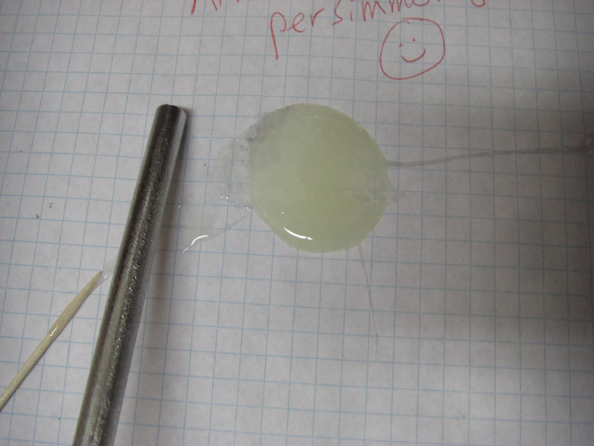

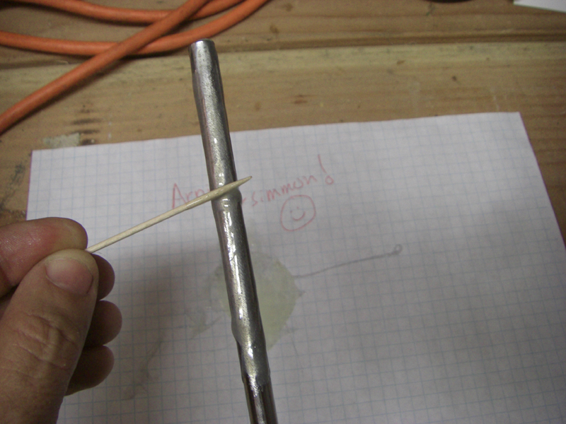

Make sure to coat the shaft… no sawdust this time…

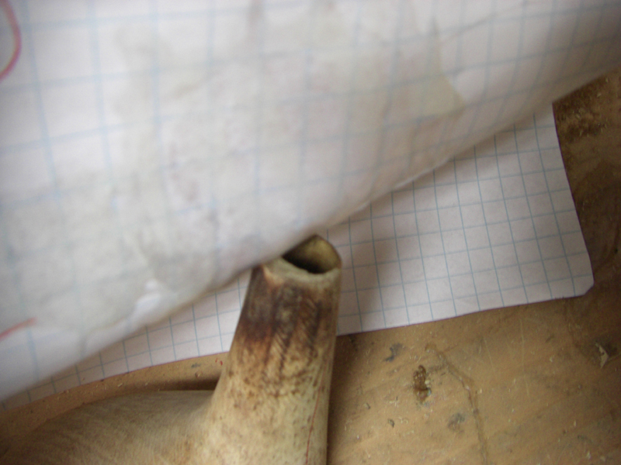

I like to just scrape off the glue from the paper to fill the hole.. Make sure the ferrule is up the shaft on the club..

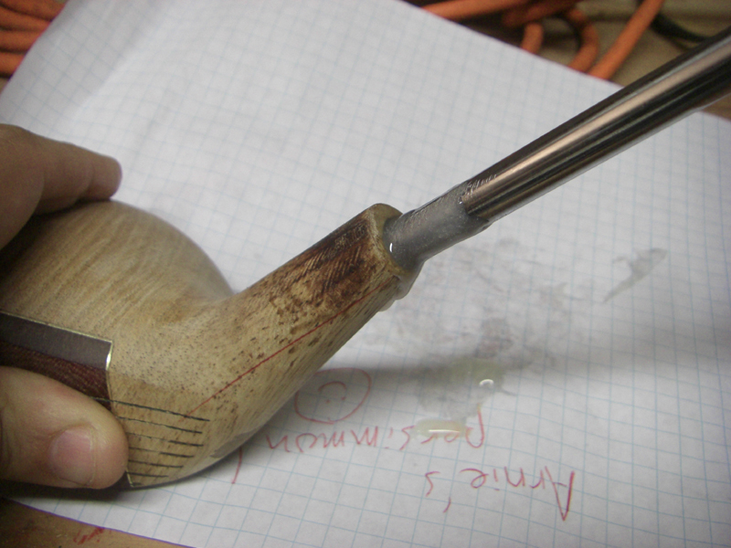

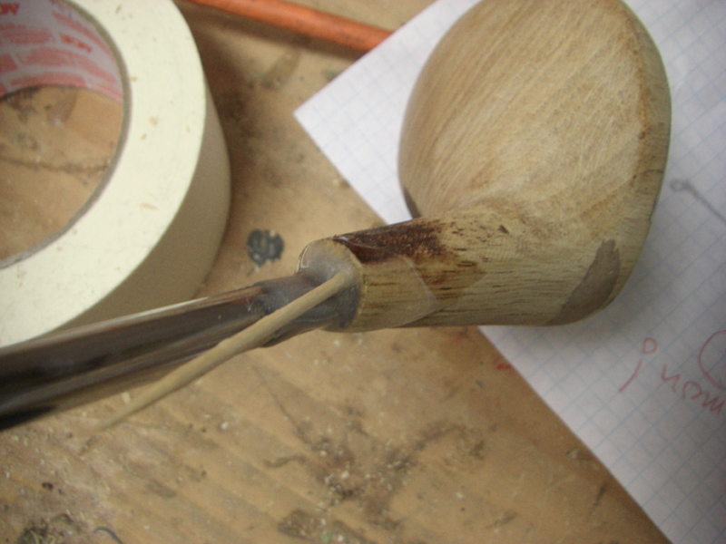

Shim it to your liking.. then let it sit overnight again!

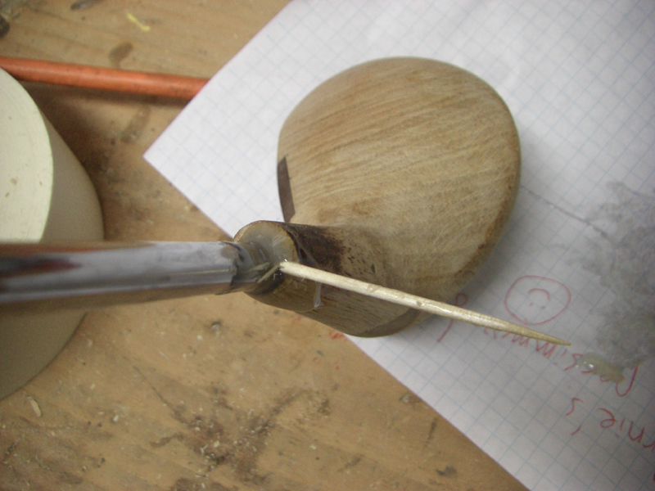

Break off your shim..

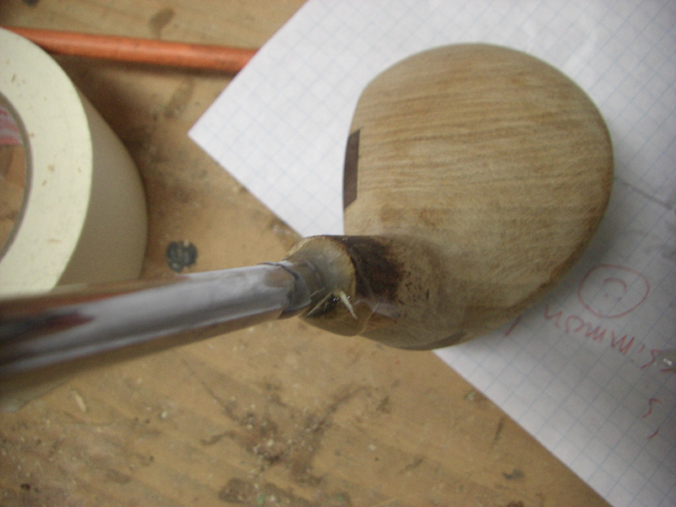

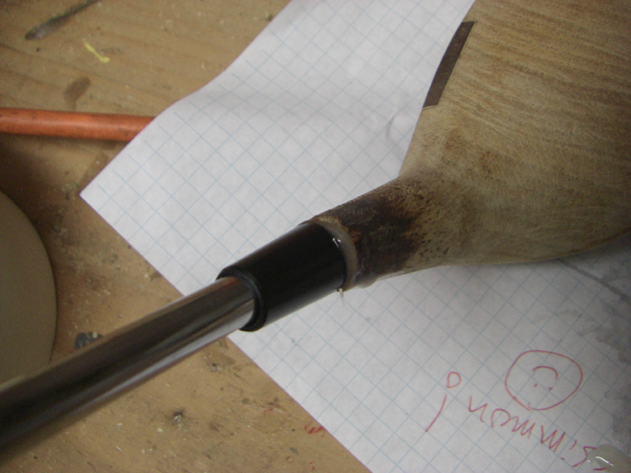

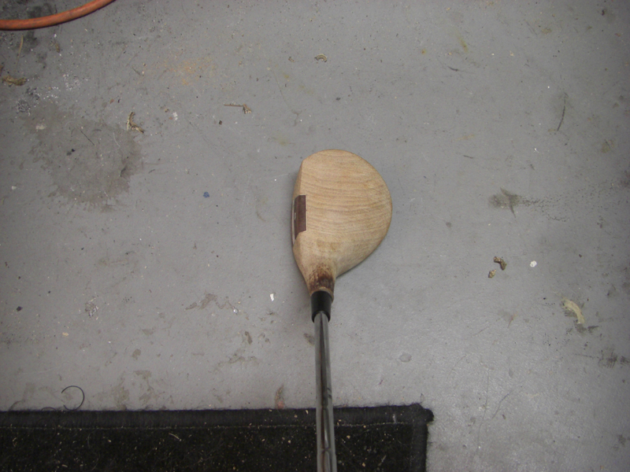

Looks good.. make sure it looks good now!

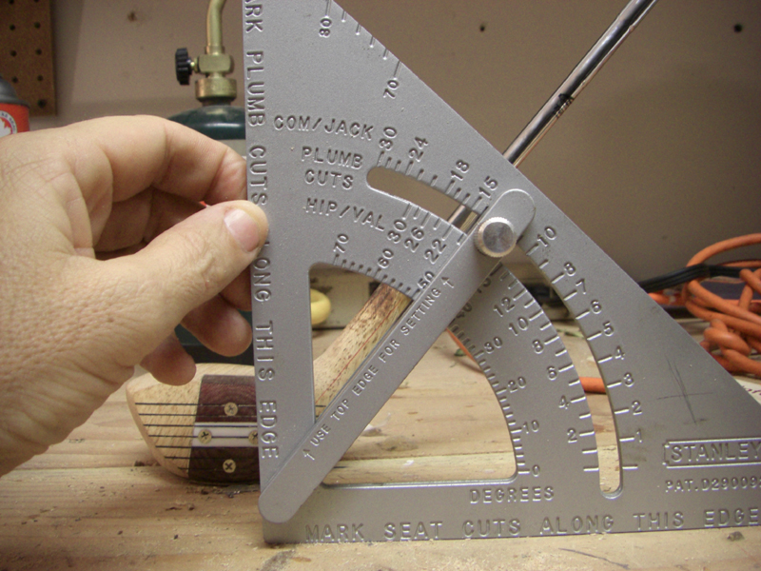

One last look at the line angle… looking good…

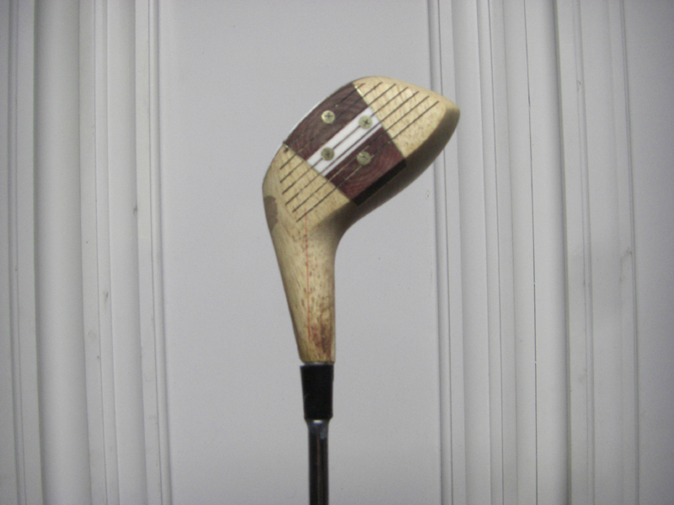

Next morning.. all is good.

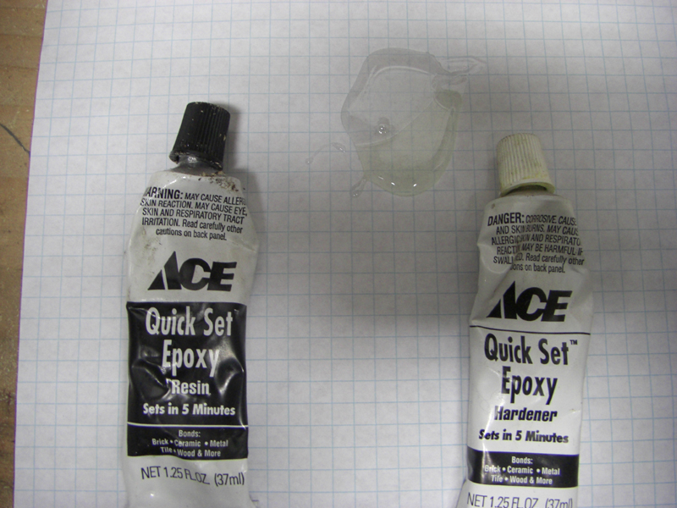

back to the glue..

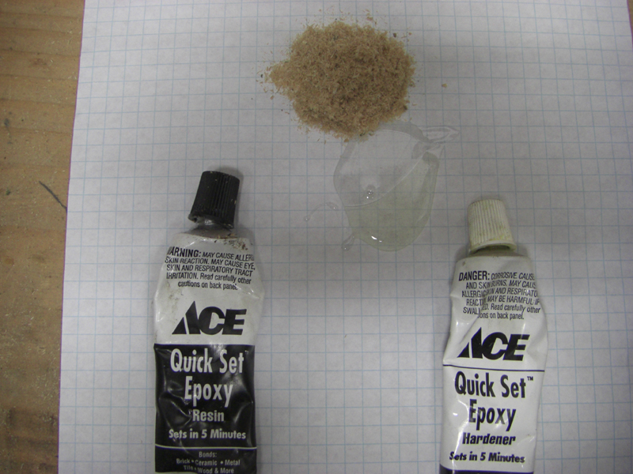

This time we can use some quick setting epoxy.. cosmetics now!

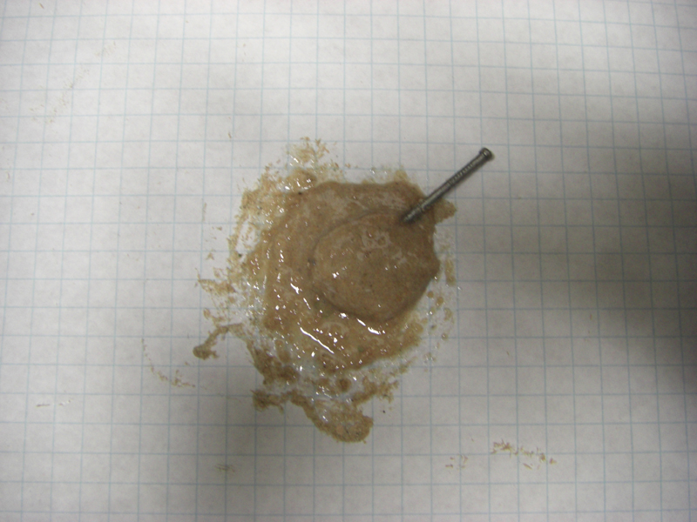

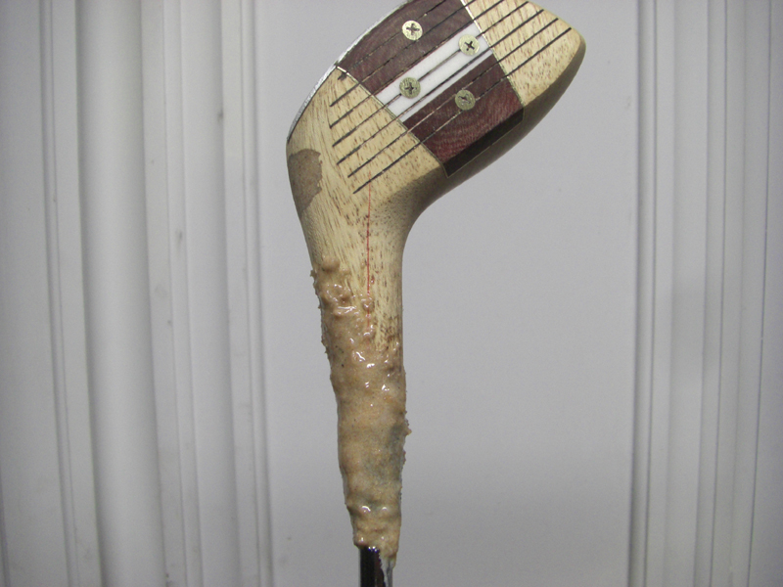

Dress the neck in the gunk.. fill in the gaps, and level out the neck some for a nice look

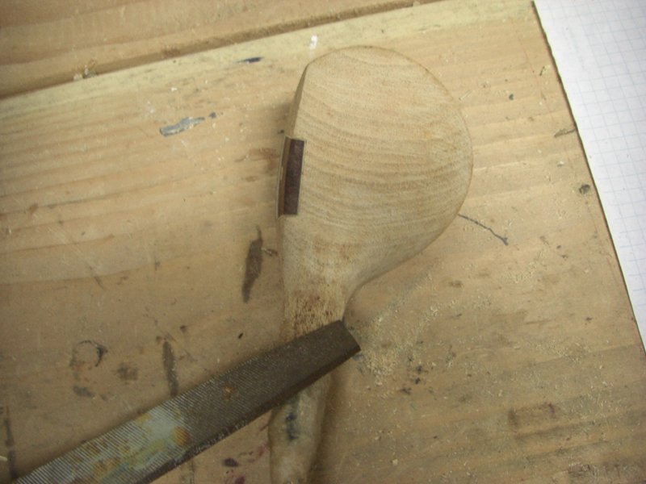

This dried in an hour.. and I removed excess with a file..

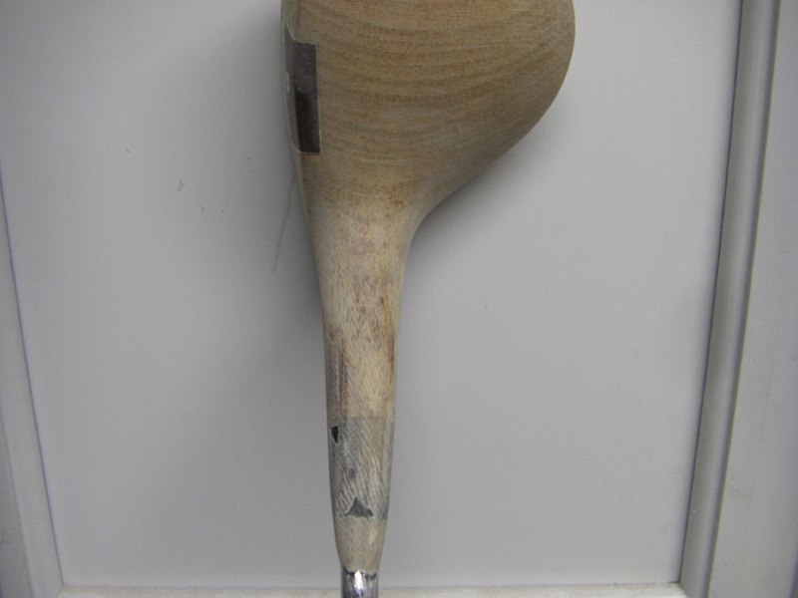

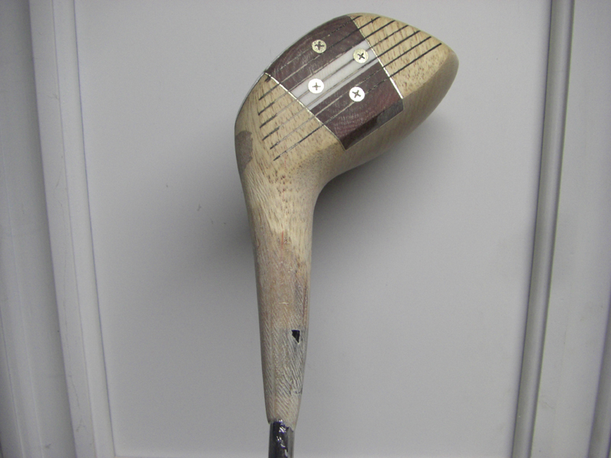

Looking good. Could put a tie on that neck!

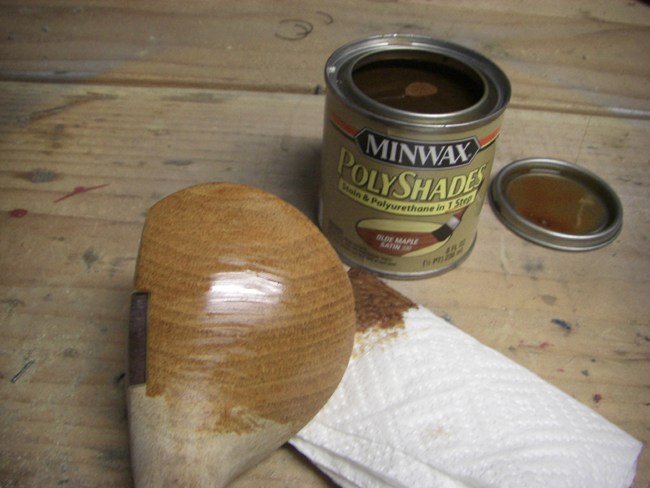

Lets stain it up… you can use any kind you like.. I prefer an oil based stain. Since the grain is so beautiful on this one.. let’s show it off with a light maple color.

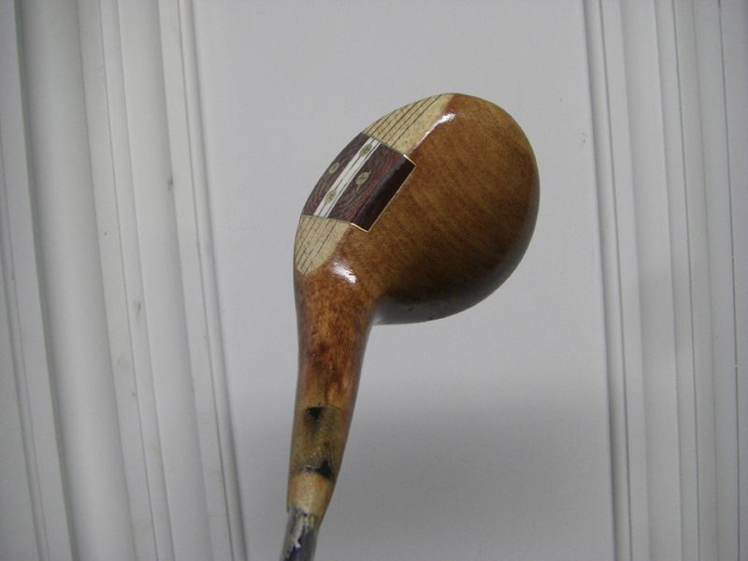

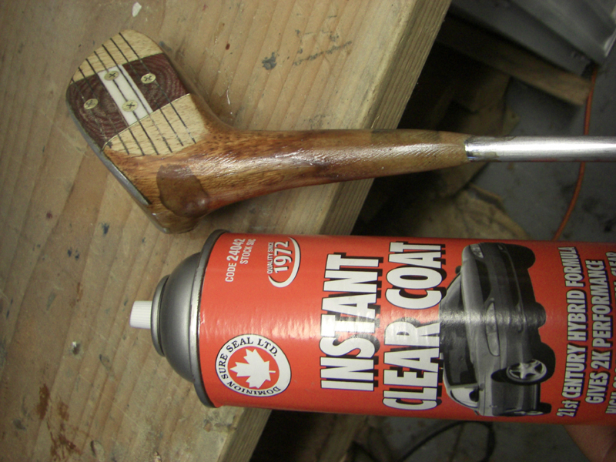

I like to let the stain dry for a few hours.. then I use an automobile clear coat. Dries really fast and goes on really smooth. Some people dip their drivers in polyurethane, but that can be a long sticky mess… This stuff works great. Any auto parts store will have stuff like this. About $15 a can.

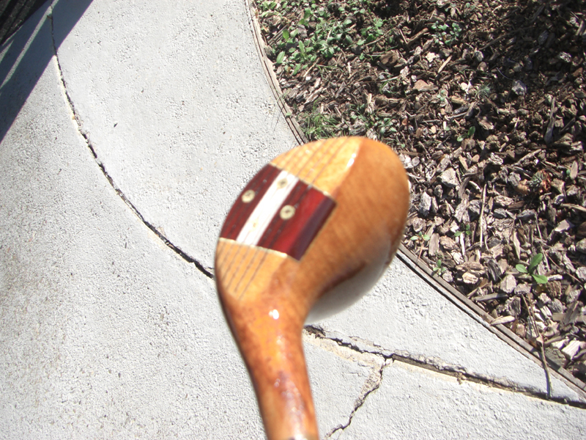

I can put on 1 coat every 30 minutes.

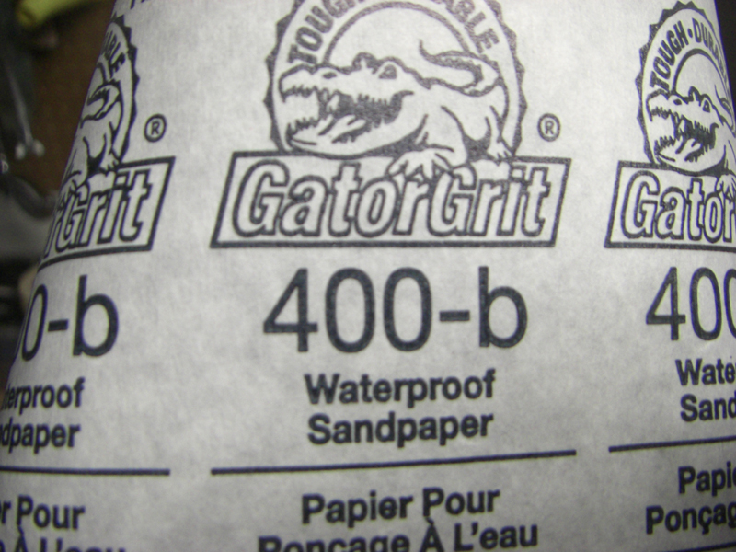

I like to sand with 400 grit in between coats

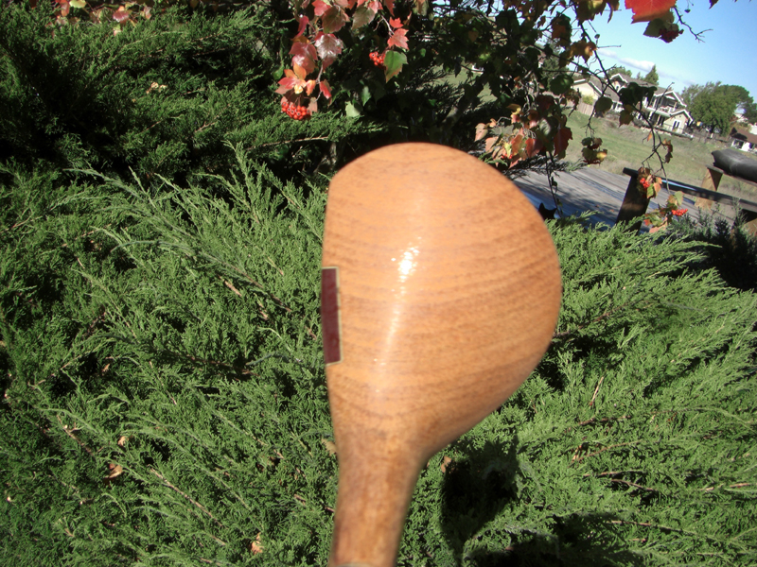

after sanding with 400
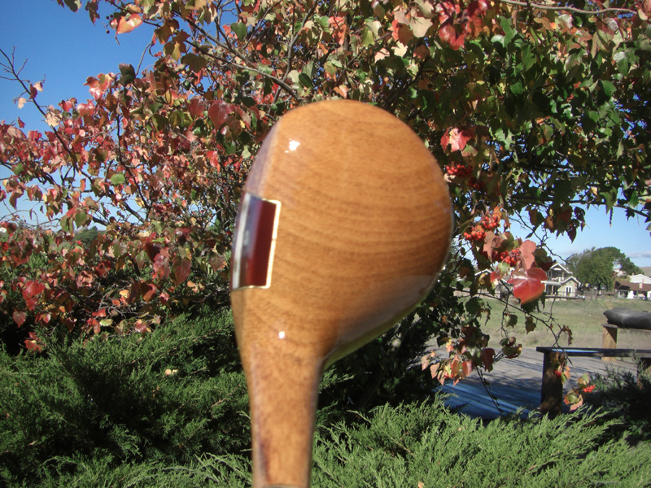

Another coat… about 4 coats and this is really turning out beautiful

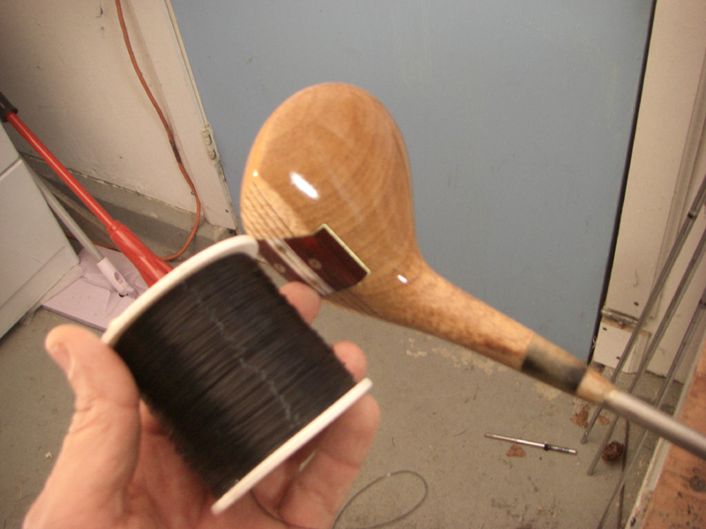

Refinish is done.. let’s dress it up with some whipping..

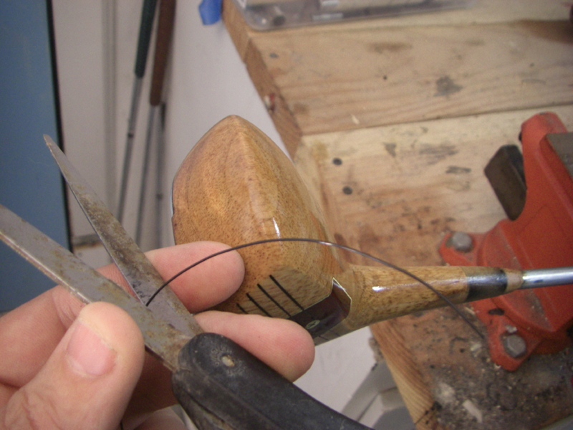

Before you start wrapping the whipping.. cut yourself off a piece about 5 inches long.. and put that aside..

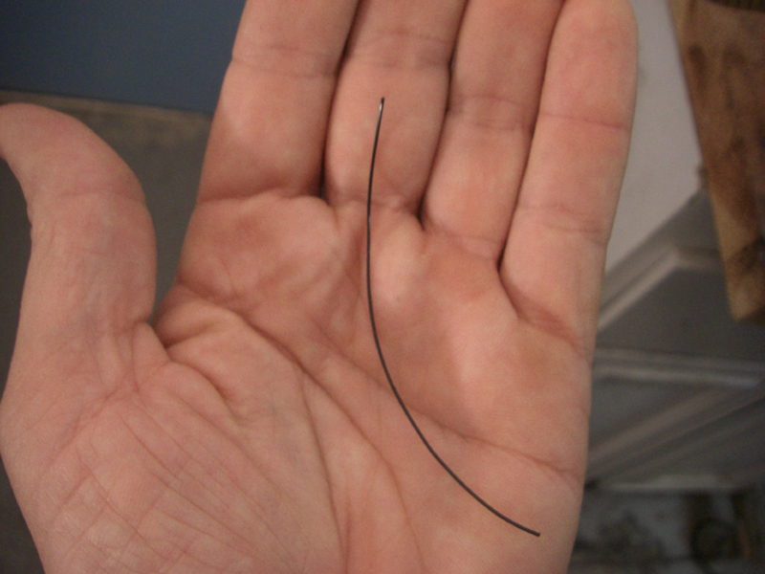

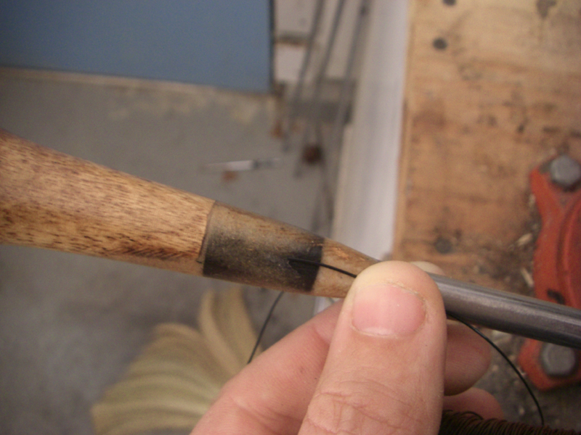

Now from your whipping spool.. start with a line going down the shaft.. then wrap over and around that..

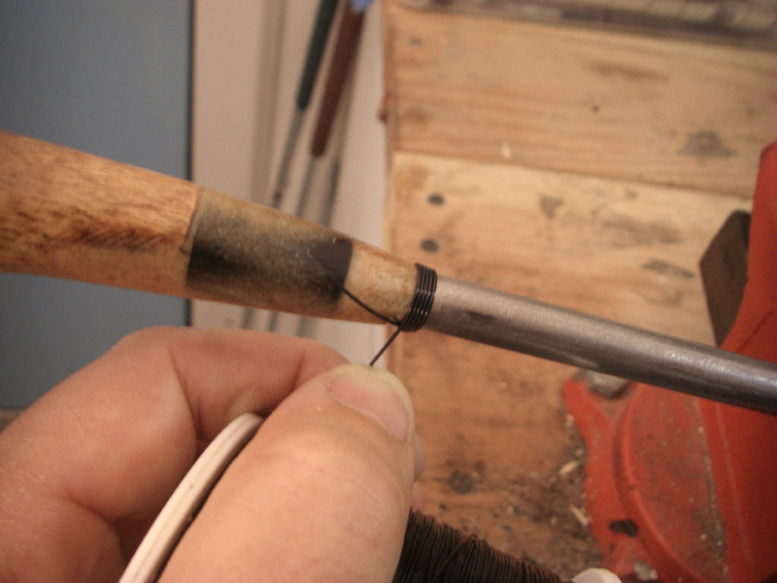

Like this…

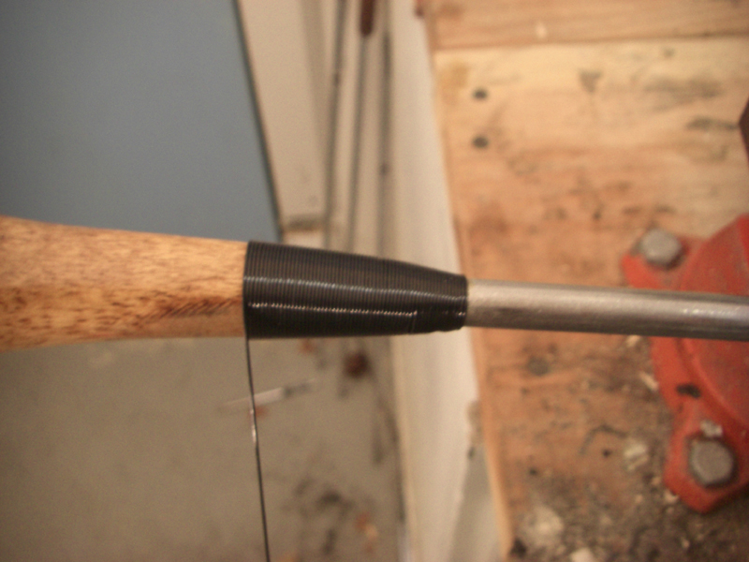

Keep it as firm as you can.. and keep wrapping the neck. The whipping will line up nicely for you because you are going up into thicker wood..

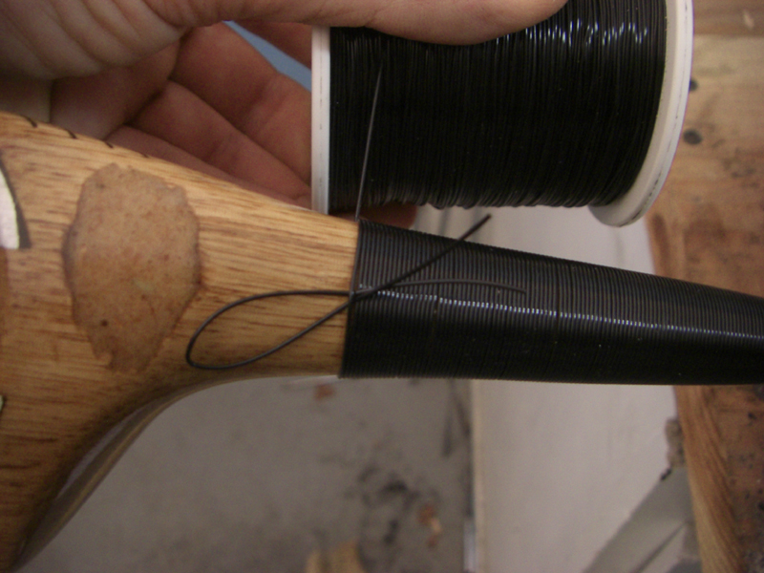

Now before you get to the bottom.. make a little loop in that extra piece you cut off, and whip over that. I like to go 8 or 10 wraps.

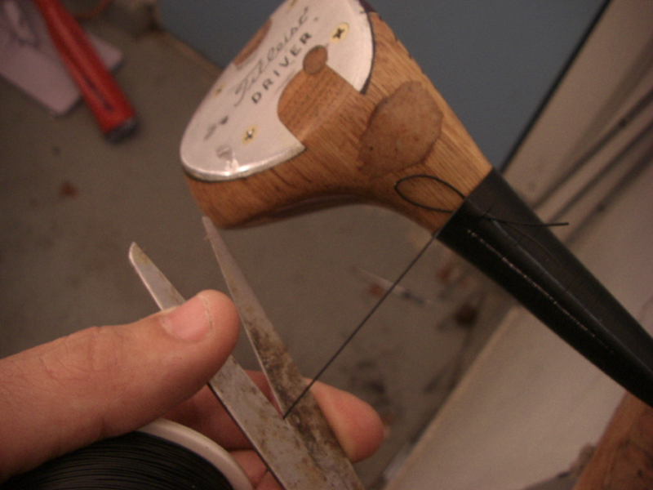

Now cut your whipping with about 3 or 4 inches… then feed it through that loop you made with the extra whipping piece.

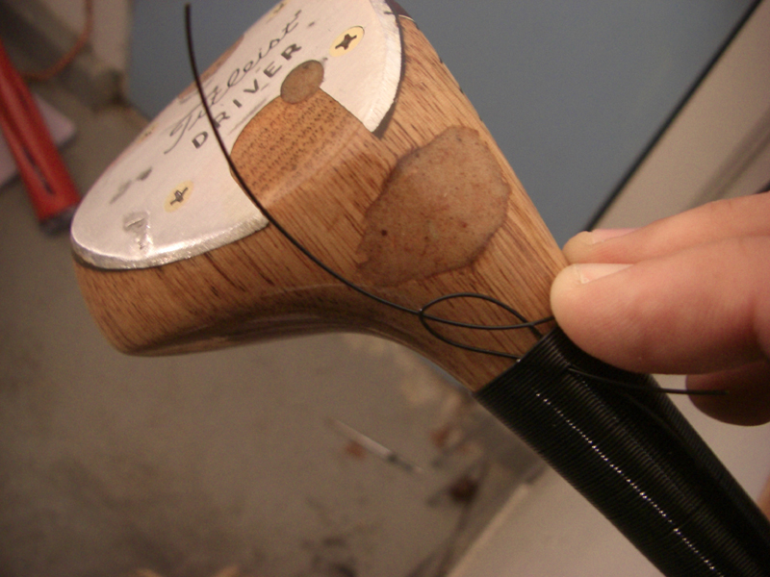

feed it through..

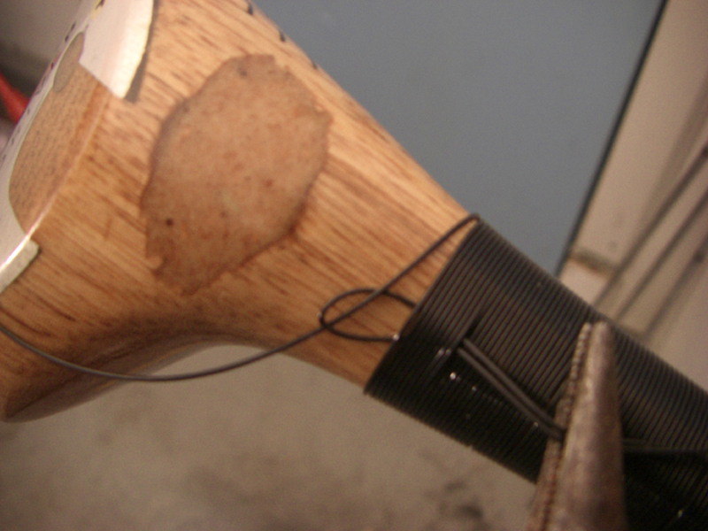

Now grab some pliers and pull it gently through…

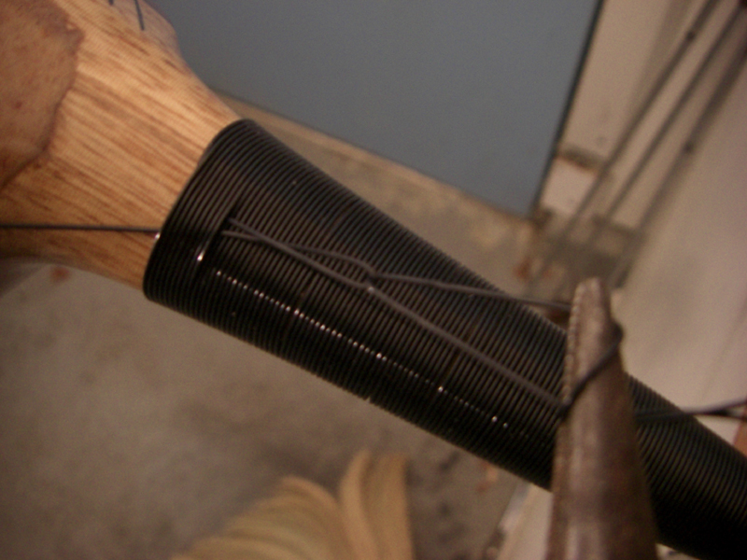

Keep pulling

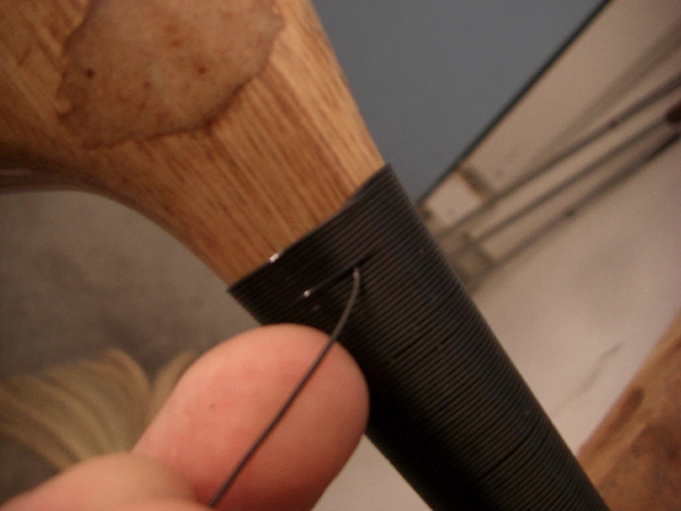

There it is..

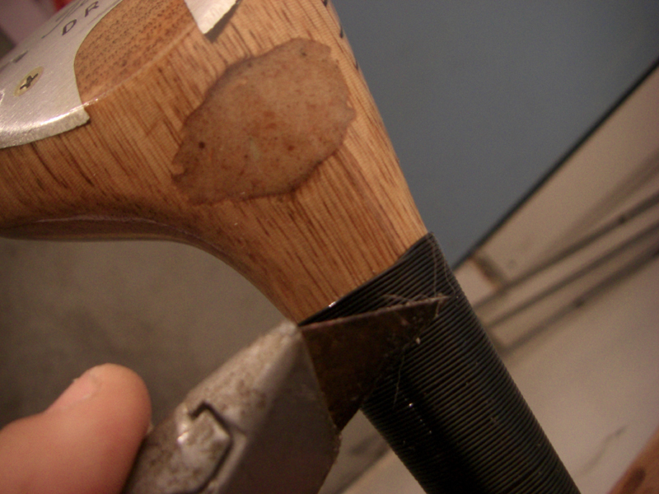

carefully cut off the excess.

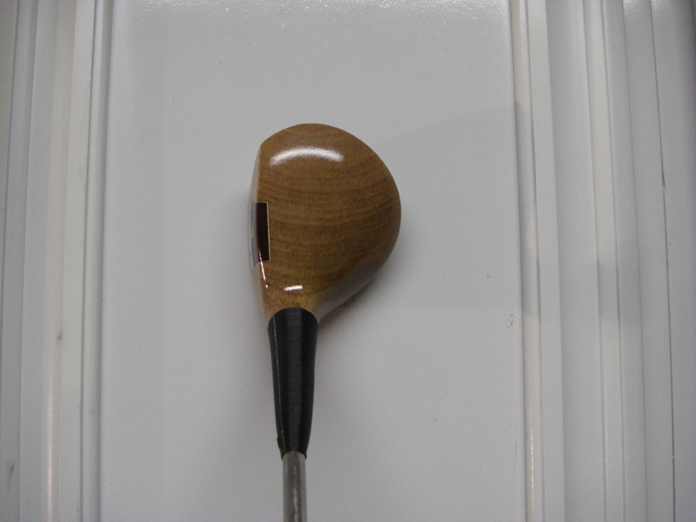

She’s a beauty..

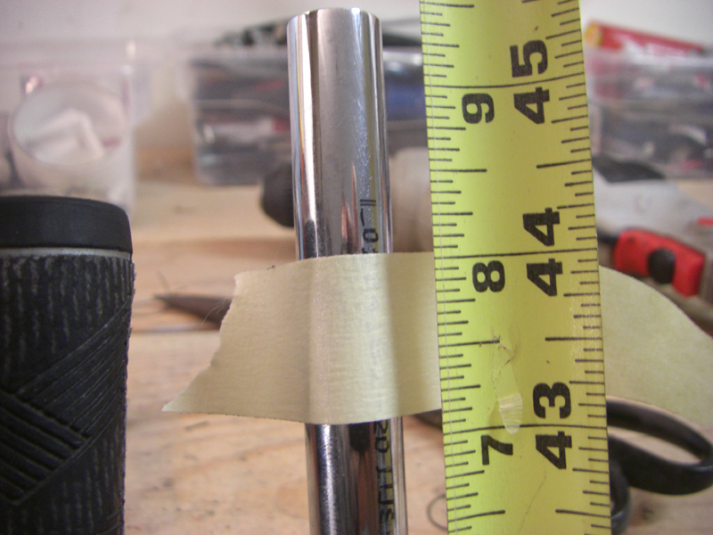

This one is getting cut at 44 inches.

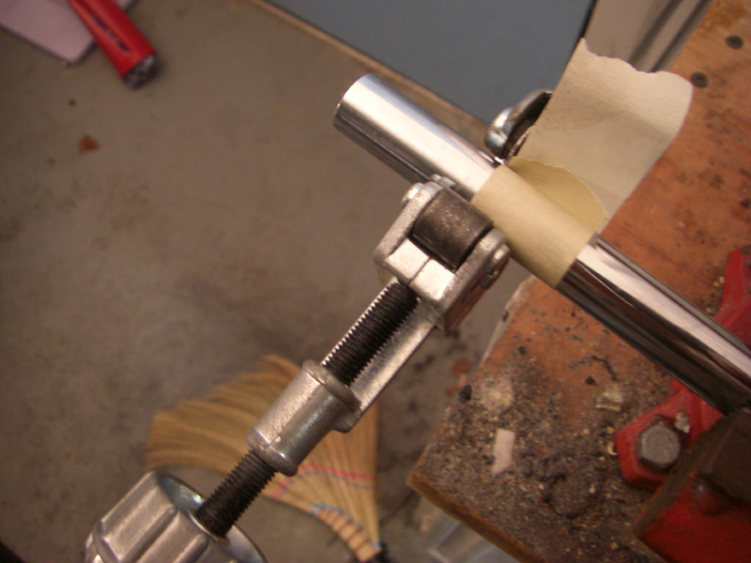

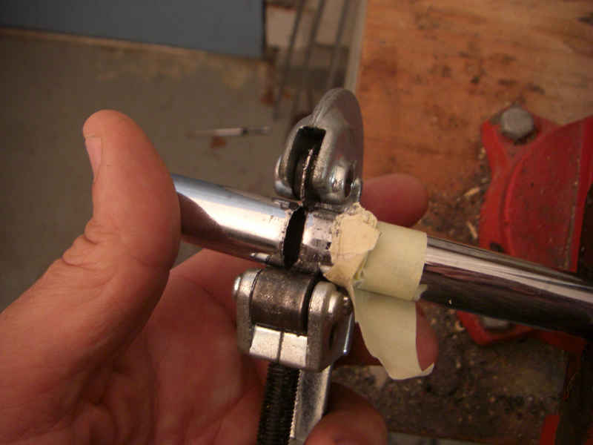

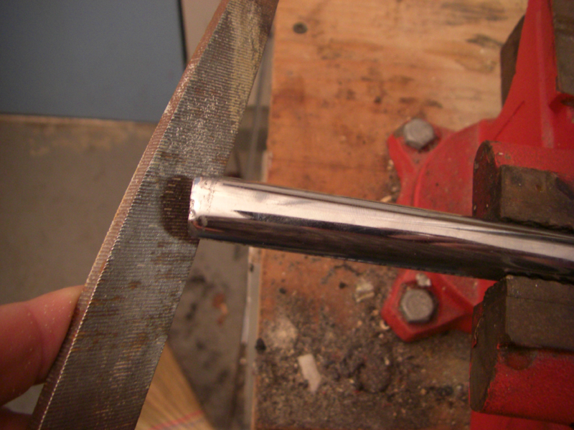

File down the grip end.

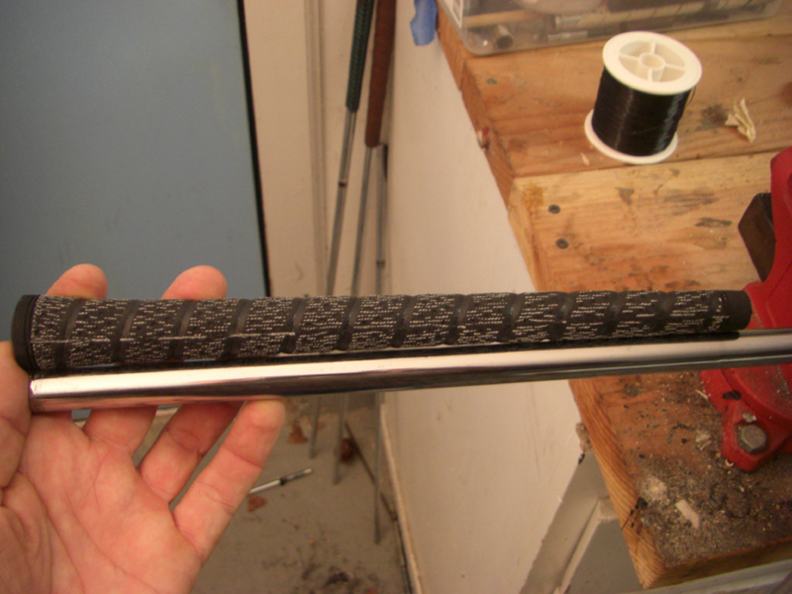

Let’s put a grip on..

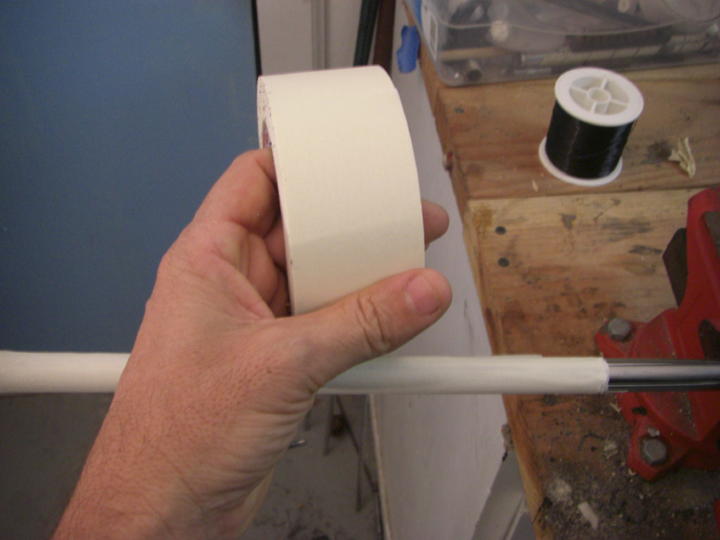

I like my grips built up just a bit.. so I use 3 inch tape, and lay three pieces lengthwise down the shaft..

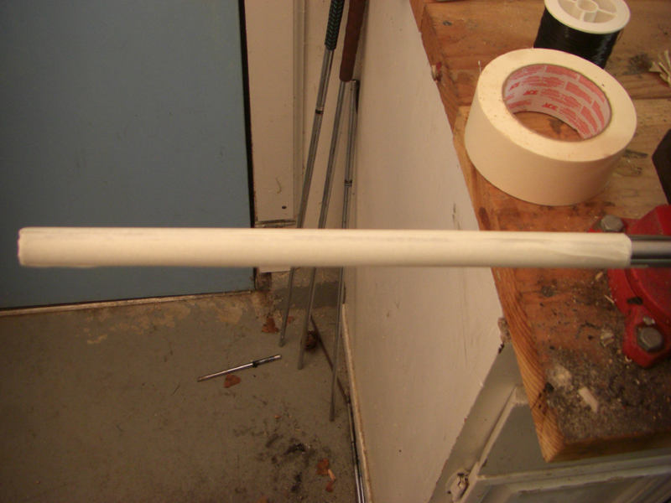

Like this..

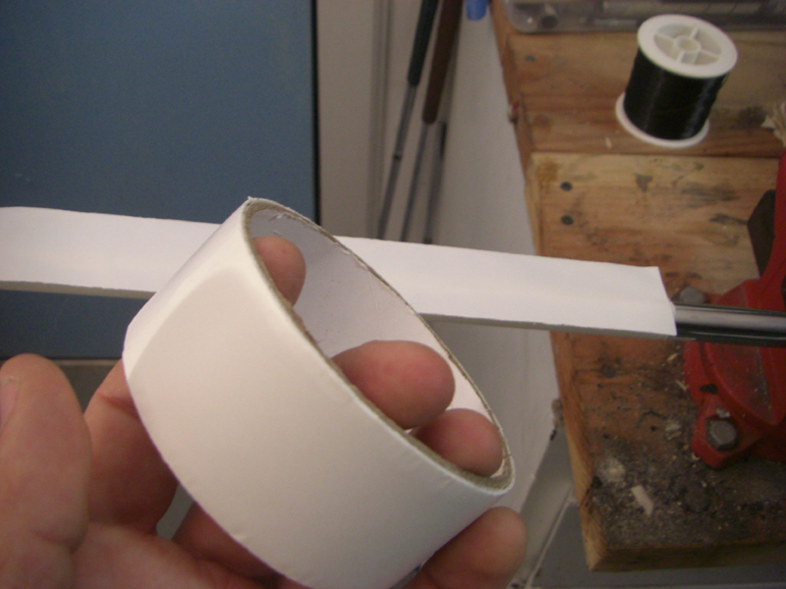

Then some double back tape or carpet tape..

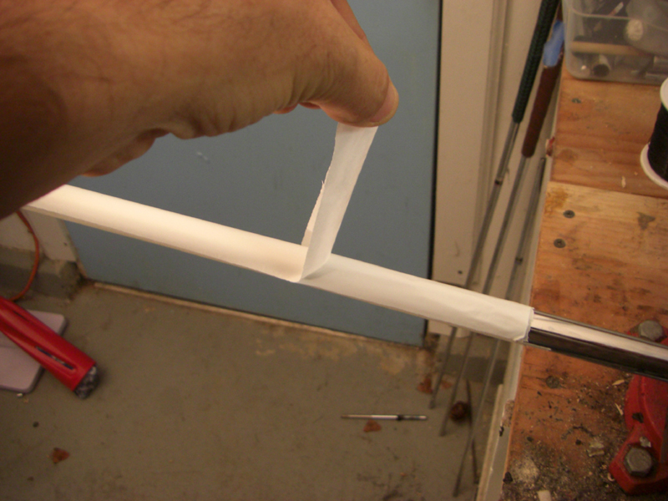

Peel off the backside..

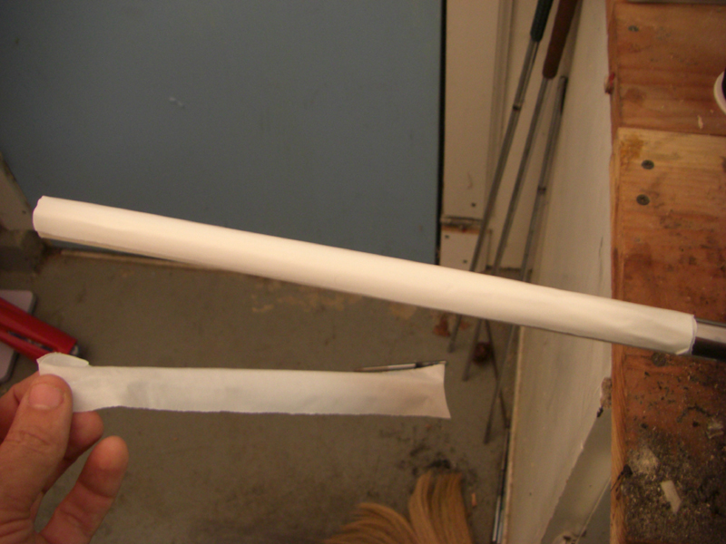

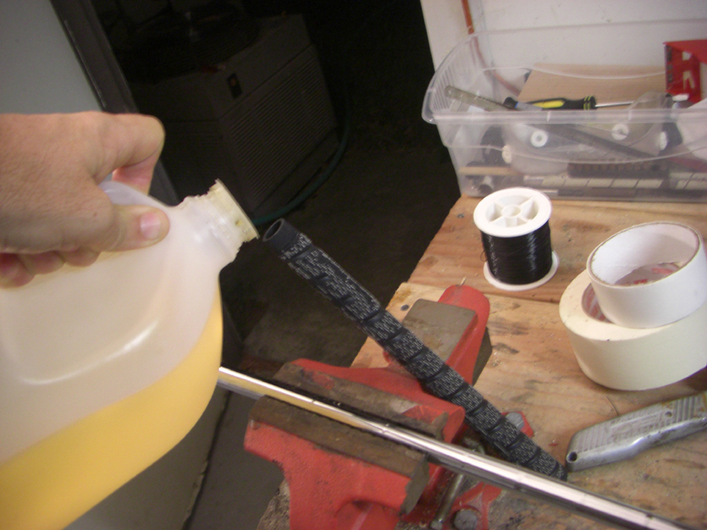

I just use soon to be extinct gasoline! Pour a bit into the grip, not a lot.. then pour from the grip over the shaft and tape… then slip the new grip on VERY QUICKLY!!! Don’t waste any time here.. it sets up in a hurry.. you have about a minute to do this..

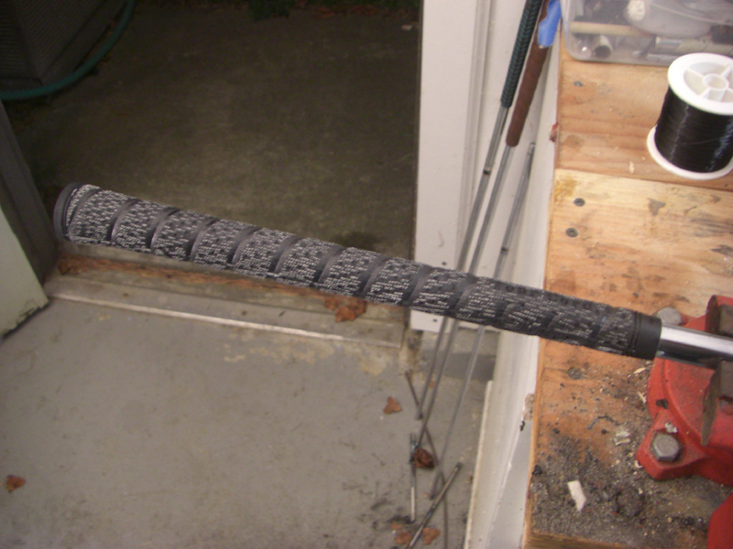

There she is with a new Dynamic Gold Steel X100 shaft, and full tour cord grip.

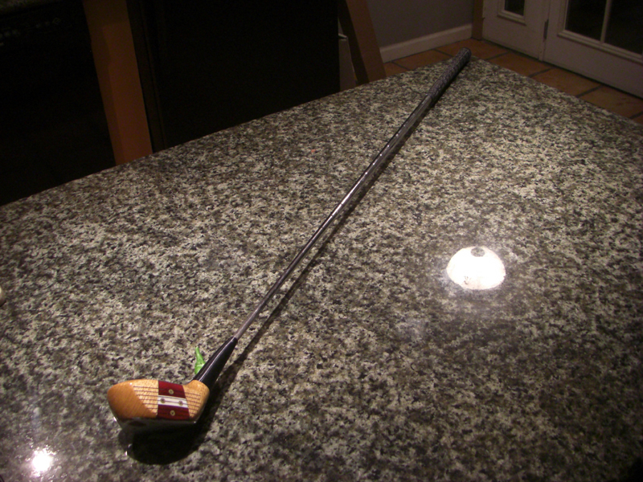

Other than a surgical scar.. on the rear, she is like new…and I have seen people with a paint brush paint a matching wood grain over the scar if it’s a bother.. sometimes you can get the pin out.. this one was a nasty one.

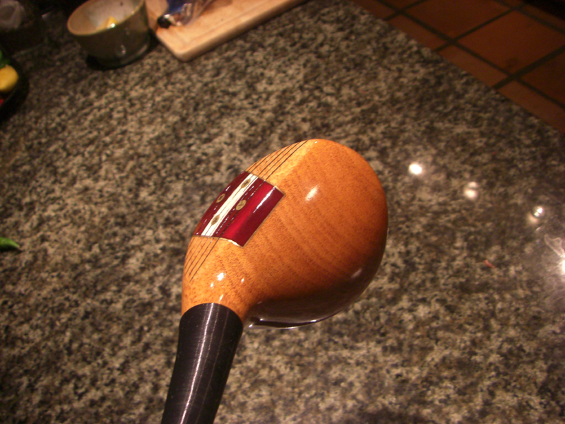

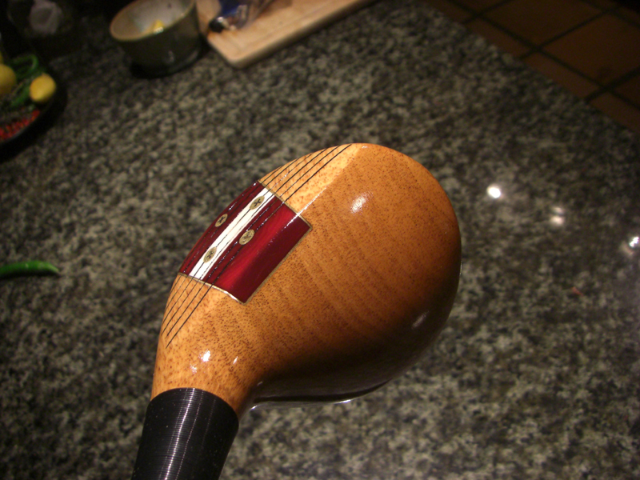

A real beauty!

It might have been more work doing this little documentary.. than rebuilding this golf club!

Hope you give it a try, and feel free to pop a donation into the paypal account if your heart feels the need to do so.. $20? (lagpressure@yahoo.com)

If you can’t sleep at night until you have a custom 10 degree flat persimmon stick like Hogan and Knudson used, I don’t mind doing one or two a month…for about $300.
But I think you’ll have a great time doing it.. that’s why I made this for you!

Lag

